ISDC 2020  
*System dynamics conference 2020*  
**Final Report - August 2021**

**Q0 - We would like to know more about your impressions of the 2020 International Conference of the System Dynamics Society, held in virtual Bergen, Norway. For each of the following statements, please indicate your answer by selecting one of the options available. Most questions can be answered on a scale from 1 = very negative, 4 = neutral, and 7 = very positive. Select “no opinion” where appropriate or if you did not participate in the indicated activity.**

**Q1 - What aspects of the virtual conference did you experience? Select all that apply.**

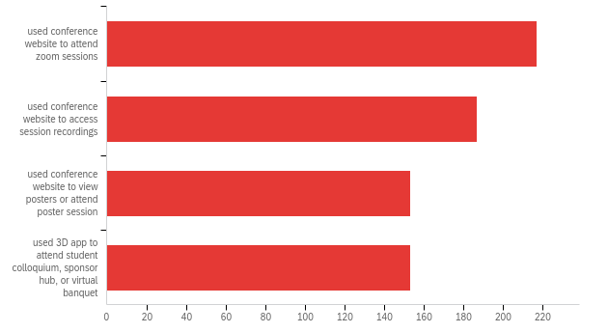

| # | Answer | % | Count |
| --- | --- | --- | --- |
| 1 | used conference website to attend zoom sessions | 30.56% | 217 |
| 4 | used conference website to access session recordings | 26.34% | 187 |
| 5 | used conference website to view posters or attend poster session | 21.55% | 153 |
| 6 | used 3D app to attend student colloquium, sponsor hub, or virtual banquet | 21.55% | 153 |
|  | Total | 100% | 710 |

**Q2 - When it comes to the content of the conference program, my evaluation is:**

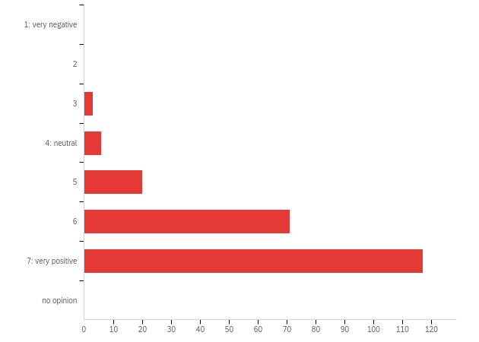

| # | Field | Minimum | Maximum | Mean | Std Deviation | Variance | Count |
| --- | --- | --- | --- | --- | --- | --- | --- |
| 1 | When it comes to the content of the conference program, my evaluation is: | 3.00 | 7.00 | 6.35 | 0.86 | 0.74 | 217 |

| # | Answer | % | Count |
| --- | --- | --- | --- |
| 1 | 1: very negative | 0.00% | 0 |
| 2 | 2 | 0.00% | 0 |
| 3 | 3 | 1.38% | 3 |
| 4 | 4: neutral | 2.76% | 6 |
| 5 | 5 | 9.22% | 20 |
| 6 | 6 | 32.72% | 71 |
| 7 | 7: very positive | 53.92% | 117 |
| 8 | no opinion | 0.00% | 0 |
|  | Total | 100% | 217 |

**Q2b - Additional comments**

| Additional comments |
| --- |
| For knowledge gaining very well. For sharing and connecting with people bad. |
| I think it's great that everybody is invited to contribute, no matter their background or subject |
| A very interesting and inspiring program, of which I wish I would have more time to attend all the interesting program entries. A suggestion is to extend the time to 4 weeks to watch the recorded sessions to enable that, as two weeks was a bit tight timewise given other obligations. |
| I'm very happy that there was an educational strand and hope that will continue as more educators become involved. |
| content of sessions good and abstract inof good to selectiing what to "attend". Did get quite confused with the echo sessions and accessing recordings. Appreciated the after conreence access. |
| :-):A bit easier to find interesting, high quality stuff than the non-virtual conference, but still room to improve that. I did not understand the difference between echo and feedback sessions |
| I found the content to be very useful and informative, with an appropriate amount of emphasis on the current pandemic. Excellent programming! |
| Spectacular conference! I believe virtual format increases and facilitates participation! |
| brillant! |
| I especially found the workshops helpful. |
| The program had a wide range of topics which provided a lot of insights. |
| I thought that most of it was very timely and relevant to the massive issues humanity is facing. |
| My impression was a personal use of the conference (plenary sessions especially) to emphasize personal research achievements, rather than foster research debate and encouraging SD neophytes in modeling and practice. |
| Overall, the conference was top-notch given the extenuating circumstances and the very short period of time that the organisers had to react. Well done! So far, it's been the smoothest and best run 'virtual' conference I've attended this year |
| Good program, wide range of topics covered, well-knowm plenary speakers. Good. |
| The content of the conference seemed similar to previous conferences. |
| Variety of presentation quality in one session |
| From content perspective, I loved the diversity of themes. From my side, I was just missing "how to fund SD projects", how to take SD models -&gt; Real world solutions, what does that process looks like |
| The SDS conference was so much more than I expected in terms of relevance to educational learning environments and systems thinking. |
| The program is great! The real challenge is to decide what to see in a timely manner. But the recorded sessions helped a lot. |
| Great workshops and very interesting plenary sessions. Recommendations: some more beginner modelling workshops... |
| I think there should be sessions oriented to potential problem owners, so they can appreciate what modelling and simulation could do for them |
| Sessions and paper quality was really good. Plannery sessions were pretty awesome specially sessions on peer mentoring |
| Very impressed with the quality and breadth of topics. Well selected. |
| I wish I could have attended more sessions live. |
| Excellent. Extremely current and relevant. It was the high quality content of the program that inspired me to join at the last minute. Would like to see more practitioner material and more discussions around selling SD and addressing needs of clients in commercial applications of SD. |
| some gems, but as in the past, too many weak presentations in prominent spots including plenary sessions. Still need to ramp up quality of papers and presentations significantly. |
| Wide range of topics |
| Overall very interesting, good mix of plenaries, parallels and WIP sessions. As someone not in the "inner circle", there is a little too much on historical achievements |
| I liked the combination of a) plenaries that reflect on the history of the field with b) plenaries on innovative applications of SD |
| I found the roundtable discussions by far most valuable |
| It was great how conference facilitated 24 hour conference through echo sessions. The organisation was very helpfull in making my presentations posible cinsidering my personal circumstances. |
| Thank you all |
| This virtual conference worked very well. I would just have liked to have some social zoom sessions that could be scheduled. |
| SDS did fantastic but need to make the easy and simple. They could use google calendar invitation so that time difference can easily traceable. |
| Echo session is too heavy duty for authors. It's easy to adjust body condition for one session, but doing for two is not. |
| Very nice |
| first time so not sure what to expect! |
| A little bias as program chair, but I am quite pleased! |
| Excellent variety |
| I found viewing posters to be the most difficult thing to do. |
| There were glitches to be sure, but overall, I was extremely impressed with how well the Society was able to pivot from an in-person conference to a virtual one. |
| It was very valuable to hear directly from the workshop leaders about their work. |
| For me the Conference was very successful! |
| In the topic areas that I was seeking, excellent work was presented this year. |
| Higehr quality papers than last year. |
| The zoom fatigue became real. It was exausting. But i am not sure if the actual conference would have been more exausting. |
| The conference schedule had a number of issues. It could have benefited from the option of filtering and sorting based on subject or keywords. It did not have the 'you are here' in time, so we needed to scroll through pages and pages of schedule. The website kept logging me off and that changed the time zone of the schedule; I missed a couple of interesting sessions because of that. As a whole, it needed improvement. |
| I had other things on my plate and so was unable to attend as much as I wanted. |
| The variety and quality to me seemed to me to remain comparable to previous SD conferences - great work! |
| The quality was as high as it always is. |
| Would have been nice to have some sort of informal way to zoom/chat with other participants.... sort of self organized breakout rooms that others could also join. |
| Would like to see more content pertaining to social issues, inequity, mental health, etc |
| Programme good but scheduling was not well thought through - all the public health sessions were running in parallel sessions at the same time |

**Q3 - When it comes to the conference website and access to presented work, my evaluation is:**

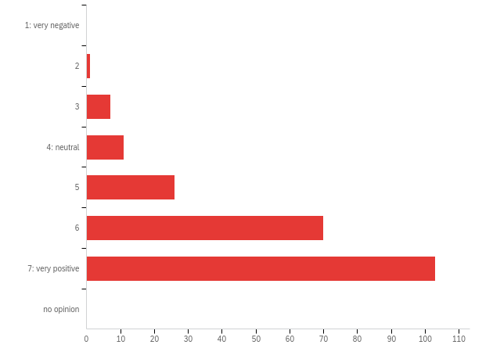

| # | Field | Minimum | Maximum | Mean | Std Deviation | Variance | Count |
| --- | --- | --- | --- | --- | --- | --- | --- |
| 1 | When it comes to the conference website and access to presented work, my evaluation is: | 2.00 | 7.00 | 6.14 | 1.07 | 1.14 | 218 |

| # | Answer | % | Count |
| --- | --- | --- | --- |
| 1 | 1: very negative | 0.00% | 0 |
| 2 | 2 | 0.46% | 1 |
| 3 | 3 | 3.21% | 7 |
| 4 | 4: neutral | 5.05% | 11 |
| 5 | 5 | 11.93% | 26 |
| 6 | 6 | 32.11% | 70 |
| 7 | 7: very positive | 47.25% | 103 |
| 8 | no opinion | 0.00% | 0 |
|  | Total | 100% | 218 |

**Q3b - Additional comments**

| Additional comments |
| --- |
| As mentioned above, I would have liked to have access to recorded sessions more than two weeks after the conference to enable to have time to dig in to all the interesting content. |
| I only had access to the web app of Zoom, due to organization security policy. |
| It was a little confusing to have separate logins for conference site and SDS website. At one point I logged in as a member, linked to the conference site and was frustrated by not being able to view recordings. It took a minute or two to realize I had to log into the conference site to see them. |
| best presentatiosn were those with prepared slides and minimal use of Zoom faces - maybe a small photo of presenter in the corner of each sllde would be sufficient |
| It was always hard to navegate across the structured schedule |
| Suggestion: use color coding (e.g. echo vs. initial); make the tabular schedule clickable, too (full text search!) I always had to use it and the clickable one in parallel |
| Outstanding job with coordinating this and making the event accessible. |
| it's great that I can watch the recordings. There is still an opportunity to improve how the work is listed and how you can search for particular presentations. Now I had to use the tabular view of the schedule in pdf and then I would go search for those presentations in the 2d online environment |
| Very well done and accessible. |
| very impressed, easy to find session and go to Zoom room |
| conference program, and with the access to zoom sessions, is hard to navigate (being in one big list) |
| I especially enjoyed live presentations; I had trouble with Echo sessions because there was not much time to watch the presentations before joining. |
| I found the daily programme a bit hard to navigate. |
| I wish there were options to filter by type of session, presenter, etc. |
| I could only get on 3d once. That was very user unfriendly. hard to ho anywhere easily. After that, was frozen out. |
| I found it laborious to scroll through the long linear list of sessions. Would have preferred a tabular or other more visual approach where possible to see a whole day at a time, I think. |
| Nice work. |
| I found the poster session timing a little confusing, and it would have been nice if when looking at the schedule you could anchor to dates, but otherwise, this was absolutely excellent - clear, well done, and well communicated. Absolutely loved it. |
| Would have been nice if the presentations of the sessions was organised more like what you would find in a conference booklet. It was annoying and difficult to have to scroll through all the links. Would have helped if it was organised by day or by theme or in a calendar-looking format. Really liked how you could tag the ones you liked and then then would appear in your personal section |
| Almost everything worked fine, even though attending the overall conference was fatiguing |
| User Experience was not up to par. Really needed help from UI expertise. Lacking adding to calendar was huge. Multiple and repetitive clicks to get to a session was daunting. For the time spent, it was fine though. |
| Difficult to navigate |
| I liked this online version more than I expected. The opportunity to view recorded sessions and participate in echo sessions was excellent. |
| Amazing work! The website could be made more user friendly by displaying the schedule differently. |
| Conference website was straight forward. Just at the beginning I was looking at the Virtual world and was not aware of the Zoom calls. |
| A little hard to navigate at first, but excellent helpdesk |
| Very easy to navigate the program and find the links to live sessions and recorded videos. |
| Loved the time zone feature for the schedule, so I didn't have to do the manual conversion. Took a little time to adjust to looking for events but having the daily schedule come up helped with that. |
| Online schedule on conference website a bit confusing. Also the 3D-App crashed every time I used it... |
| Really great job! |
| The online conference schedule with adjustable time zones and favorites worked very well. I found it quite easy to access zoom sessions and drill down to papers and other supporting materials. The 2-D poster sessions also worked well in terms of easy access. However I had difficulty with access to the 3-D poster sessions. |
| I was sometimes confused having to log-in to the website and then to the conference. |
| The website worked well, but the schedule was hard to navigate as many fairly tall items appeared between dates and times, making it easy to get lost. |
| one item for improvement: navigation through the conference schedule was slow, especially on the last days |
| The format of the most up-to-date schedule was a bit difficult to navigate because it was one long list and only listed chairs unless you clicked on specific sessions. It would be helpful to have an easier to navigate search function to search for specific authors. |
| The website could include a quick search |
| The schedule was incredibly difficult to interpret, even when the local time was set to your own time zone. It would have been nice to see some sort of standard calendar view with chunks of time and a better way to see what sessions overlap. |
| the time table was a bit confusing. I missed an important session due to my confusion about the time of the event. |
| The conference website schedule can be better designed say as a calendar integration from with search options to reduce much scrolling and missed notifications. |
| It would have been good to split the schedule by days. To have the whole schedule in a single page was sometimes confusing and time consuming |
| Everything was easily accessible it became kind of addiction. |
| Wonderfully organized, wonderfully executed. Bravo! |
| You did an enormous amount of impressive work in a short period of time. Overall though I would say the effort was seriously over-designed: too many moving parts, too needlessly complicated, too many sometimes confusing announcements and links. I guess I finallygot things figured out a few days before the event after a lot of wandering through the several web sites and a good deal of confusion. When I was able to attend the tutorial and also to reach out to the help desk they were promptly and effectively helpful. |
| Found the time zone corrections very useful. |
| I thought the "Schedule" did a good job of managing the challenge of multiple time zones. When problems arise the excellent "help desk" support team was there to help. I was also pleased that the site was kept up for a while after the conference. |
| Could be more accessible if arranged in a calendar format - look at long time with the scrolling |
| It was all there and up to date. But that long list was overwhelming sometimes |
| The conference team did an *outstanding* job organizing and delivering the virtual conference. Hats off! |
| I liked that it was so simply, but an index of events so that I could quickly locate a link to a specific presentation would have been useful. |
| The schedule could be made more modular - separate sections for posters, workshops etc. |
| Hardly any technological problems |
| It would have been useful to have a schedule menu to (re)access easily the details of any day |
| Some things werent very intuitive. e.g., Finding a presentation of a specifica author |
| I would have liked papers to have been searchable. I spent time checking out almost every paper looking for specific keywords |
| online schedule was not easy to navigate. very messy to have just one looooooong list, you have to scroll up and down all the time |
| It was structured way of presenting the schedule. Making a personalized schedule was very helpfull. I experiences some late difficulties with last minute change for presenting at the poster Echo. |
| minor: the date for sessions would have been helpful to reduce scrolling up and down |
| Web page can be simplify |
| Linkage to recorded content was confusing. Zoom links would vanish before the session of the link completed. |
| When I save a session to my favorite, it bounced me back to the top. |
| Access to the original and recorded sessions were easily accessible via the website. Having recorded sessions was TERRIFIC!! |
| The conference was great. I could attend in parallel sessions that were at the same time. It was not possible in the past conferences. Also, I usually come with my kids and cannot attend the workshop. I participated in three workshops and they were super helpful. |
| It needs too many clicks to arrive papers. And, it's not clear that the page has link to papers or not. Similar design but different condition pages exist. |
| I often found troubles with Zoom. I am unused to Zoom because it is a prohibited application at schools and universities. |
| Very nice |
| The website responded very well to changes to the webportal and made it easy to see work. |
| It was confusing and a bit challenging to navigate but I'm giving a mostly positive because I WAS able to access everything I needed to and the task was highly complex! |
| I only presented a poster but it was found. |
| Sessions were not much different (cognitively) than "being there". I only missed the social aspects. |
| I still maintain the time shown for NZT was an hour out! Not a big deal once that is known. |
| The conference app was nice, but it would be better to have it organized in a less convoluted fashion. It was visually hard for me to find all the things I need with everything being listed all in one place in one long list. |
| While convenient, somehow the schedule browsing could be improved. |
| After you learn how the website works, then you are all set. But the learning curve might be slow. I hope you keep this system for next years too. |
| The schedule was overwhelming. It could have been made more user friendly |
| I give you an A+ for trying innovative approaches. The 24-hour schedule and the way you implemented it seemed quite positive. |
| It would help to use paginations and filters to browse better the list of options |
| felt like there were lots of clicks needed to get into the conference. |
| Easy access overall |
| I couldn't get into a "private" Zoom room for the second session of my poster presentation, but otherwise the technology worked really well. |
| overall, very good content but I did have some problems. I marked several sessions as favorites but couldn't find a way to get back to favorites. Also, I think the presenters could have been MUCH better prepared to go right into the content. There was too much "oh, I can't find the presentation," or it's not sharing properly or whatever. I realize this is a learning curve with Zoom, but I've seen too many professional webinars that look like they're coordinated by the producers of the Oscars. Zoom can deliver a very professional production but the presenters have to get everything set up. You might also look at a much more heavyweight conference platform like VMIX, which may be overkill but... |
| It went so smoothly! |
| Not the easiest to sign up to and then get used to, but good functionality |

**Q4 - When it comes to the 3D app, my evaluation is:**

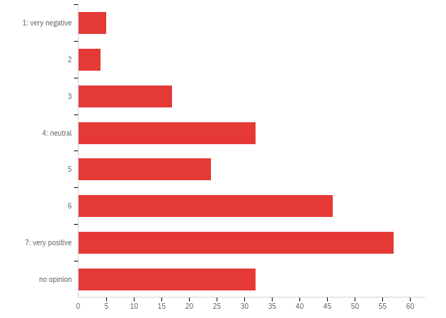

| # | Field | Minimum | Maximum | Mean | Std Deviation | Variance | Count |
| --- | --- | --- | --- | --- | --- | --- | --- |
| 1 | When it comes to the 3D app, my evaluation is: | 1.00 | 7.00 | 5.41 | 1.53 | 3.06 | 217 |

| # | Answer | % | Count |
| --- | --- | --- | --- |
| 1 | 1: very negative | 2.30% | 5 |
| 2 | 2 | 1.84% | 4 |
| 3 | 3 | 7.83% | 17 |
| 4 | 4: neutral | 14.75% | 32 |
| 5 | 5 | 11.06% | 24 |
| 6 | 6 | 21.20% | 46 |
| 7 | 7: very positive | 26.27% | 57 |
| 8 | no opinion | 14.75% | 32 |
|  | Total | 100% | 217 |

**Q4b - Additional comments**

| Additional comments |
| --- |
| Gives some fun but not really usefull. To look around the booths was okay. Mostly passive. Difficult to approach people, not possible to attrack people to your booth |
| This was a great way to meet people informally and mimicked fairly well the experience of an in-person conference. |
| I really appreciated the 3D space and made some good connections there! My only regret was that I had limited time to attend the 3D-space while it was open, and wished it would be open during the whole conference. Further, the technical platform did ot make it easy to distinguish who was speaking to you, which is a technical matter that would be good to work on if ever used again. |
| I tried it but got no further than navigating the home base. It was interesting but with limited time I just wanted to get to the substance of the conference. |
| probably quite a lot of time to set up and maintain - not sure it is ncessary |
| I had no time to see it |
| One time I had to log out and in again and walk all the way to the banquet again, so that people could hear me. my suggestions:show real faces (pictures), possibility to switch to video-chat, replacement for interest badges (e.g. matchmaking platform) |
| I had difficulty navigating, Usability testing would help. The instructors were not sufficient. |
| It was a neat experience and did add some of the experience of "running into someone" that a real conference allows. However, it was a bit glitchy and overloaded my computer a bit. So... I think the idea is good if we have to do more virtual events, but the technology still needs work. I can see the benefit of where it can go! Oh, and adding a handshake or other greeting would be good for the avatars, instead of so many dance moves. |
| A first for me! I'm thankful I just upgraded to a high capacity laptop, as I heard others saying that the size of the application almost blew theirs up. ;) I thoroughly enjoyed the experience, though initially wasn't clear on how to move my avatar or how to talk to others using the mic. I eventually figured it out. Also, with regards to the virtual banquet - many of us were searching for a gathering place for it, but were unsure where to go. People were a bit scattered which made connecting more difficult. Excellent experience over all, though. I really appreciated the Bergen cultural touches and virtual view. |
| It's a great app, there is still room for improvement though (e.g. to make a talking circle adjustable, in some cases it was too big), the poster part can also be improved in a sense that there are not so many clicks needed to get to the poster pdf. |
| suprised, very fun, could have been used a lot more, for banquets every night so people could "meet" |
| It was rather difficult to handle the avatar, navigate through the VR, and attend the presentations of the posters. |
| The circles, in which you could listen to and talk to people, were to big, especially for the poster sessions. |
| wish I'd spent more time on this |
| There were issues with the sound. Often I was unable to speak with fellow avatars. Furthermore, it would have been nice to have a map to click on to get to various platforms since it wasn't easy to find the relevant portal to access the various platforms. |
| I had some issues with audio but am not sure if it was on my end. My microphone didn't work. |
| I did not find time to log into the 3D app |
| It was interesting. I'm sure younger participants who are famililar with gaming liked it. I didn't really feeling comfortable using it to stike up a conversation to network. |
| I was unable to run the app because my operative system is a Linux distro. C'mon it is 2020, it should be possible to do so |
| Great experience...I had some nice converstions there. |
| I couldn't navigate to the different towers and after entering once and having a lovely time that included a live conversation with another attendee, I could not sign in again. No one could help me deal with the error message--I was disappointed. |
| One word: meaningless. |
| FIrstly, I have to say that the app was pretty excellent! At the banquet, the voice did not work well - I feel like there were a lot of people thinking that they could be heard, when they couldn't, and it was a little dizzying being able to hear some voices but not all. But overall, so so excellent! |
| The concept was great and the construction was impressive (given the timeline) but I don't think, overall, it added much. It was hard to find people (you end up running around trying to get close enough to see who each avatar is), and by providing only their name (instead of a link to who they are) it made it difficult to network. Would be nice if there was a visible list of who was in the 3D map, as well as the ability to 'tag' a name (of perhaps someone you wanted to talk to) and then they would have a little star or something floating over their head. |
| The app did not work on my laptop. I really do not why |
| Improve voice and text chat for localized groups. Add more public events there. The banquet was not really a banquet. |
| Was not able to access due to bad key for first 2 days; lots of people lost; difficult to tell what was available; difficult to talk with people through app |
| I accessed the 3D space only once, to try to participate in the banquet. I had a steep learning curve for this format and got frustrated so I left after I wandered around for a bit. However, I did see things that I would have liked to explore more. I'd like to see this again in future conferences -- maybe there could be a "training space" for those of us who don't play video games! Also, I would have come back to it when I had more time, but it was already closed. So maybe have it open longer. |
| Very nice experience! I would have included conversation prompts or other silly games to get people talking. |
| It was a good touch. I think it took great effort and was a creative solution. Maybe my biggest problem is that I did not find anywhere to talk privately with people and see their faces in the virtual world. Sometimes, the crowded area I could hear several conversation + Zoom, so it was hard to manage. It was missing a personal chat in that virtual world |
| Very exciting and hoping next year there will be another virtual 3D environment. The only reason it is not a 7 is because there can be improvements to the environment like the sound bugs but it is completely understandable given the short time that was available to develop and test the software. |
| It would be better if we can read the posters more conveniently. |
| Fun |
| The 3D app was amusing! Excellent work! |
| It worked really well and it definitely was one of the highlights. I had very nice "face-to-face" conversations with colleagues while walking around in the 3D world. |
| Tried it twice, my laptop crashed every time... But what I saw, was nice (design, UX) |
| My internet was too slow |
| Couldn't get it to install and work on my laptop |
| I liked the idea in principle but in practice found myself distracted with operating the avatar controls and excessive crosstalk. I also felt like a bit of a recluse as I wondered around the 3-D space, encountering friends but not really able to engage with them. 3-D posters were difficult to find and lacked the resolution to be easily readable. |
| I really wanted to access this but never got to it. |
| Some improvements could be made, but this was the closest we got to being in person! |
| The ability to hear others talking with sensitivity to proximity was great! |
| great job. Sometimes the voice channel wasn't working perfectly, but I guess it's normal provided the short time to develop it |
| 3D was super cool. |
| Regretfully I did not use that feature. |
| Had some fun and some frustrations. |
| My computer, an older MacBook Pro. Issued warnings when I tried to download. Though the always supportive "help desk" offered to take over my system do download the app, I decided against this. I would have preferred that the resources of the society would have been focused elsewhere. II would have happy to use the app if had been adequately beta tested, but this still would not have been a priority. |
| Amazing aplication! |
| The 3D App had problems with voice communication. |
| Amazing! Blew my expectations out of the water. Was still possible to bump into people old and new for ad hoc conversations like the real thing. Generally prefer face-to-face but this was a really successful second-best! Well done! |
| I suggest there could be improvement in the interface and navigation with the avatar as well as around the space, but also I am not an experienced user/familiar with that environment. Perhaps it would actually been useful to have a 'learning workshop' previous to gathering in events - perhaps next year. Because I didn't enjoy/ could not navigate and speak well at the colloquiom, then I didn't join the other 3D events. As experimentation and learning is sometimes a barrier to innovations, perhaps some assistance could be useful.Thanks. |
| It is cool, it helped me to start getting into the conference mood. But I didn't connect to new peers too much in there. |
| great idea; not ready for prime time (based on virtual banquet). |
| I loved the concept but did not really know how to navigate the environment. Needed a help function or a cheat sheet. |
| Continous use lead to overheating of my laptop and eventual shut down |
| Great idea. Sometimes difficulties with the sound so that |
| the conference posters could also have been included in the 3D space, not only the colloquium posters |
| Overall a very good first experience |
| during the conference days only single-user mode was accessible (I would like to interact with other avatar, but I understant the internet band limits) |
| Though it was so novel and fun, that it was almost distracting from the conference content. But it was a great experience, and I was really impressed! |
| Sometimes a bit frustrating but funny :-) |
| I think the 3D was a fantastic first attempt at replicating the real experience. I was quite pleasantly surprised at how it mimicked the true experience of "walking around" among the posters. However, there is obviously a lot of room for improvement here. To begin with, for example, the choice of the avatar was not well-designed, having to click between avatars randomly. It would have been a lot better if you could select the 'core' avatar among categories (male/female, short/tall, formal/informal, etc.) And then you had the option of adjusting it to your preference using different outfits, etc. Also, it would have been nicer if we had more 'planned' and synchronous sessions in the 3D world, such as participants all gathering around at the same time to listen to another 'avatar' give a talk for example, e.g. for one of the award sessions, and they could then mingle and talk afterwards. This would have increased the chance of making chance encounters and better replicating the real experience. I hope we won't have to use a 3D world again, but if we do, this was a very interesting starting point and I hope to see lots of improvements next time round. Well done Ninad! |
| App was very slow and not usable for me. However, I am using an old MacBook which might not be the best Hardware for 3D Apps :) |
| 3D app lacked some sort of announcement feature, where organisers could talk to everyone verbally. |
| The regular poster presentations should also be included in the 3D world, like the colloquium did. |
| I could not access that application |
| Favorite Part |
| sort of fun, but in the end not that useful |
| It's hard to find thing, the map couldn't help. It might be more user frindly, if there is a list of posters at the starting point, like an information board, which we can click and go to the target area. |
| Navigation took too much time. I had to start over several times. During the banquet I lost the ability to speak to others or hear them. The idea has good potential but too many bugs. |
| I admit I accidentally hit R a few times while searching peole’s Name. I then was redirect to the main page. |
| I like the idea of the 3-D activities. My ability to navigate was not great. I did really appreciate the ninja helpers. |
| I was struggling using it in my IMAC but it is a rigorous way to attend. I hope this will continue even everything will be settled. |
| Interesting, but not very useful. |
| Interesting |
| certainly added some fun! it was neat experience...more guided experiences in that environment would be useful |
| good fun but I spent more time navigating round than actually at the posters or stands |
| difficulty installing and resource intensive; yet fun for some things |
| It was fun to connect with people real time but it made me motion sick =) |
| Took a while to get used to it - but I did "bump" into some people! |
| It was clunky (Second Life-ish) and I was not able to navigate very far into the sponsor booths. Also, I mostly was unavailable at the times it was open, which was frustrating. Would have liked more open time. |
| Easier movement through an interactive map feature would have been nice. |
| Awesome! Awesome! Awesome! |
| A nice substitute for the live opportunities. |
| I only sampled it briefly. I had trouble initially accessing it until I got some help. It felt too artificial to be really enjoyable. I preferred interacting with people via Zoom whenever there was an option. |
| I did not find it easy to use. Perhaps it was a problem with the user. |
| Really great idea. I imagine it will get better with time if we need to use it again. |
| Some difficulties with sound. At some of them were due to my bluetooth headset. |
| It was fun, and I chatted with a few people. Not a replcement for in-person interaction, but still nice. |
| The only issue was that sometimes the audio (space key) did not work properly. And a chat function with single persons would be a nice thing. But that's no complaint. It was great and lots of fun! |
| I would prefer special discussion zones in front of the poster. Within the radius alle participants can hear. The Zoom session does not worked realy as all were debating at the poster. |
| My only comment here is that in a conversation with multiple attendees it was hard to know who is talking. |
| I got in briefly Sunday for a test walk, but, even with 30-40 minutes help, I was unable to attend the banquet. Still, I like what it promised, and I hope you can use something like it again with the bugs worked out. Prima! |
| I had some issues with the mic on day 2. And that kept me away form some interactions |
| there is a learning curve, and I felt that there may have been value in ADDITIONAL use of the app, for example in all poster sessions? |
| Instead of just making it OK to be at a virtual conference instead of the live one, it made it additonally fun! |
| I didn't use it. |
| Wold be nice if avatars had the operators actual picture |
| Really enjoyed this although the banquet would have benefited from more structure. For newcomers it was very lonely |
| Awesome |

**Q5 - When it comes to the services provided by the conference organization, including technical support, my evaluation is:**

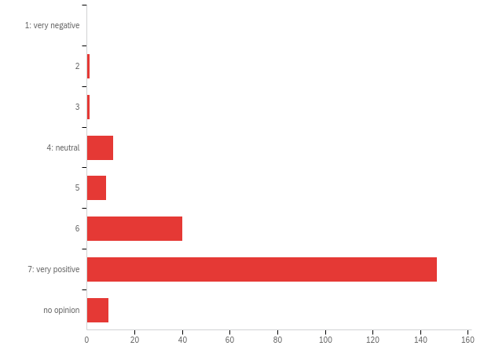

| # | Field | Minimum | Maximum | Mean | Std Deviation | Variance | Count |
| --- | --- | --- | --- | --- | --- | --- | --- |
| 1 | When it comes to the services provided by the conference organization, including technical support, my evaluation is: | 2.00 | 7.00 | 6.55 | 0.84 | 0.85 | 217 |

| # | Answer | % | Count |
| --- | --- | --- | --- |
| 1 | 1: very negative | 0.00% | 0 |
| 2 | 2 | 0.46% | 1 |
| 3 | 3 | 0.46% | 1 |
| 4 | 4: neutral | 5.07% | 11 |
| 5 | 5 | 3.69% | 8 |
| 6 | 6 | 18.43% | 40 |
| 7 | 7: very positive | 67.74% | 147 |
| 8 | no opinion | 4.15% | 9 |
|  | Total | 100% | 217 |

**Q5b - Additional comments**

| Additional comments |
| --- |
| Got swift replies regarding some technical issues! |
| :-): assistance for getting from 3-D gate to banquet |
| The team did the best they could. I think it was probably extremely overwhelming, given the number of people asking questions, but overall it was fine. Maybe some more tutorials of how to use the 3D space would be good. |
| Great and responsive technical support!!! |
| spotless |
| Took several emails before I received a reply from the conference email adress |
| It was quite easy to navigate the conference based on the information you shared with us. Thank you! |
| I volunteered for the SD Colloquium so I was on the ISDC Volunteers whatsapp group so I got insights that other regular conference participants may not have received. I never had to use the "help" function on the website. However, I received assistance from Roberta via email when I experienced issues with the website which was very helpful. |
| Response was sometimes delayed and people could not always help, but were always well intentioned and nice to interact with. |
| Great supporters' and chairs' job. |
| I sent a few messages to the chat, and they were immediately answered. The volunteers at the 3D space were so sweet! |
| Some were brilliant, some were not so skilled. |
| We received constant support and the volunteers were great |
| Amazing tech support. Thanks. |
| Great, answered all the questions. I think they were amazing. |
| Support was great 95% of the time. There were one or two instances where the support was not completely reliable. |
| Extremely polite, responsive and helpful. Insanely great! =) |
| The zoom office hours that presenters were supposed to be at were not super helpful. There could have been more of a structure/schedule to things that were covered and it should have been clearer who was there for what purpose. It did not really make sense for people to be sitting in the 'audience' not able to test any of the technical things and those who were testing things were doing it haphazardly, so I didn't even end up testing my presentation video at all. I think it would have made more sense/been more efficient if the program chairs for each session set up time to go over technical support with their groups. |
| Excellent idea to have a support person for each session. |
| Very helpful and friendly |
| Very responsive team |
| Overall the technical support was good, especially when one considers the range of conference activities being supported online for the first time. However there were some glitches. In a WIP echo session I chaired the zoom support person announced a swift departure and left me in charge of the all the webinar controls. |
| So amazingly responsive-- great teamwork! |
| Clearly so much thought and effort went into this! |
| Quick and to the point response. |
| ny glitches in the sessions I attended were minor and quickly fixed. |
| Found everyone very helpful. |
| Under the circumstances, I think the conference organization did better than could have reasonably been expected. , I |
| A lot of messages |
| Too many emails! |
| Well done! |
| Everyone very kind and responsive, from email to the chat |
| The team was amazing. I know it was a tremendous amount of work, but it paid off -- congratulations to you all |
| The TA people were excellent. They were really on the ball and always courteous. |
| everything seemed to go smoothly, impressed with the organization that must have taken. |
| The people answering the chat were not helpful at all. I asked questions and I got standard copy-paste answers |
| Many session chairs either actively discouraged or did not mention to turn on the cameras, which reduces the interaction. |
| supportive questions were answered quickly. The mistake with time and zone for the SDC SIG meeting was solved in a pragmatic way |
| Rebecca Niles was very helpful and persistently "solution-oriented" (she supported me until the problem was definitely solved) |
| Thank you |
| They always responded when I had trouble with zoom or finding something |
| On line chat was great. |
| Having tech support for each presentation was AMAZING. And the tech support people often when beyond just their required tasks. I presented 3 times and each tech person was great!! |
| The team worked excellent! However, some sessions seem to set co-host wrongly. |
| Chat staffs helped me. Thank you! |
| Working hard |
| amazingly responsive! |
| PLenty of help given |
| Tech support was readily available and things WORKED (in general, anyway). Which was amazing given the circumstances. |
| the chat reaction was not always quick, but I assume someone was overloaded by requests.. |
| Again, there were glitches, but I was very impressed with how well things went given the technical challenges of quickly adapting to a virtual format. |
| Outstanding result. It must have taken huge commitment. |
| The volunteers - Alan especially, were amazing. Thanks for rescinding sleep to make this conference a success! |
| The Society volunteers were on top of it! |
| 10! |
| It was great |
| I had occasion to ask for help getting into 3D on Sunday and again for the banquet. People were very responsive. On Sunday, it worked. For the banquet, it didn't work, but the support person suggested I wasn't the only one with problems, and solutions were complicated by the Singapore-based developers not having overnight (to them) support available. |
| Extremely fast and helpful responses of the chat; great welcoming and navigation guidance in the 3D world. |
| The chat responded quickly to my issue with the poster Zoom, but was not able to solve the problem in a timely way. |
| I didn't need any tech support but it must have been good because everything went so smoothly |

**Q6 - When it comes to the opportunity to socialize at the conference, my evaluation is:**

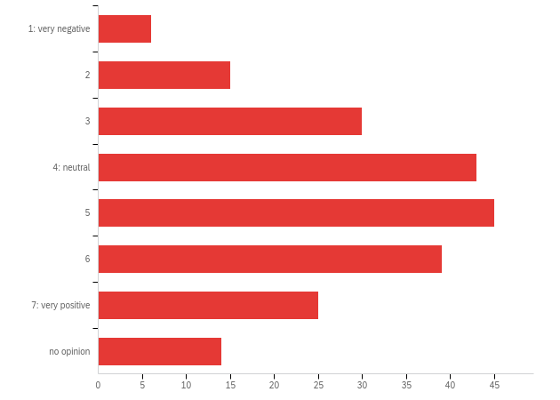

| # | Field | Minimum | Maximum | Mean | Std Deviation | Variance | Count |
| --- | --- | --- | --- | --- | --- | --- | --- |
| 1 | When it comes to the opportunity to socialize at the conference, my evaluation is: | 1.00 | 7.00 | 4.80 | 1.44 | 3.00 | 217 |

| # | Answer | % | Count |
| --- | --- | --- | --- |
| 1 | 1: very negative | 2.76% | 6 |
| 2 | 2 | 6.91% | 15 |
| 3 | 3 | 13.82% | 30 |
| 4 | 4: neutral | 19.82% | 43 |
| 5 | 5 | 20.74% | 45 |
| 6 | 6 | 17.97% | 39 |
| 7 | 7: very positive | 11.52% | 25 |
| 8 | no opinion | 6.45% | 14 |
|  | Total | 100% | 217 |

**Q6b - Additional comments**

| Additional comments |
| --- |
| The 3D app was about as good as one could expect with a virtual format. I also liked the sponsor meetings/chats on Zoom-rooms. |
| the digital meetings take getting used to. that's why I'm moderately positive. I would encourage a periodical digital general meeting |
| Good given the circumstances of it being online. |
| The 3D app didn't work for me because of interference other discussions. The only time I socialized was at the zoom session of colloquium and the peer review session on thursday. |
| Important though I didn't take the opportunity. |
| As a person participating the ISDC for the first time, it was difficult to start conversations with others, especially those from the community you do not know yet. Thus, meeting in person is crucial to socialism and to get in contact and extend your network. |
| did not manage this given time zones ( GMT+12 hr) |
| my suggestions: video-chat, matchmaking platform as replacement for interest badges, |
| Got to meet quite a few people at the sessions, but didn't have a lot of socialization time in the 3D space, especially with so many technical challenges. Not sure how this could have been done any better, though.. |
| I enjoyed that one speaker stayed longer on the Zoom to chat with anyone wanting to stick around. I found the speakers to be more accessible in some instances than they typically are at an in person conference. It was easy to ask questions using the chat function. Socializing was more of a challenge, for the reasons mentioned above with the use of my avatar and finding people congregating where I could join in. I felt odd going up to groups that were forming - I didn't want to interrupt. Of course, this happens in person, too. Maybe in the future there could be designated areas for people to gather for ad hoc conversations clustered by areas of interest? Not sure how to resolve this. |
| If I was not in some whatsapp groups with the people at the conference, I would barely have talked to anyone. The 3d environment needs to be exploited more and people need to be encouraged more to go there. it can be made like some kind of a game with quests that will facilitate interaction (e.g. talk to 10 new people today) |
| Spectacular conference! I believe virtual format increases and facilitates participation! |
| could have used the 3D avatar a lot more, f.eks directly after Zoom sessions |
| I did not socialize at all, since I was attending sessions in between other work duties :( |
| My main experience was the Health SIG which was a good, friendly meeting and most enjoyable. |
| Sometimes it was difficult to socialise in the 3D world since the sound was unreliable. It was a pity that the 3d world closed on Wednesday since it was a great way to meet new people and pump into people that I encountered in the zoom sessions.. |
| Very well considering the situation! But to be further improved if a virtual conference is continued to be offered. |
| It was harder to jump into a conversation and know when I should speak/not interrupt someone in the 3D world. I prefer using Zoom's meeting rooms/breakout sessions and having video on. |
| I did not personally socialize at all during the conference. I attended many sessions, chaired two sessions, and presented in one session. The interaction with audience members of those sessions was very good. But I did not bump into anyone outside of those sessions and have a chat; the online format may simply not be able to capture that important aspect of attending a conference. |
| Since we could not meet in person this was a great option! |
| Used the zoom a lot, but only was seen once out of many zoom sessions. everyone else seen what giben a chsncr to talh tseem |
| Getting locked out of the 3D space limited my experience. Being in California, I was challenged to attend live poster sessions while also trying to attend sessions live or recorded. |
| 3D environment ineffective. |
| All things considered, this was very well done. The echo sessions were a little more sociable because they tended to be smaller, but I have to say (obviously) that there weren't as many easy connections as there would be in person. |
| Given the circumstances, I think it was good. It was definitely way less than an in-person conference, but I'm not sure if I have any constructive suggestions on how to improve it, so |
| It was different from other conferences and in the end it worked. But I would not say that this really good |
| Would have helped to provide opportunities for small group video chat and text chat (slack or similar) |
| I liked the chat function for having side conversations. I wonder if there would be a way to have virtual coffee breaks with an open zoom room. I can see how it might be possible in the 3d app, but that seems like a lot of unnecessary visual/digital overhead to have a conversation. |
| It would have been nice to somehow integrate forums (think Reddit) where people can discuss the work at any time. |
| Considering this was an online conference, i think the socializing aspect worked quite well! |
| From one side, I could hear what other people thought in a conference, which is extremely positive, but we were missing "outside" or during breaks where people could network or something. Other than that, the conferences were the most dynamic I have ever seen. |
| The virtual environment really made this great. The only reason it was slightly difficult I think, was because not everyone went to the virtual 3D world. I woudl propose that next year there be an official item that helps people get into the virtual world and a crash course on what you can do. I think this would greatly enhance the interactions in the 3D world. |
| With all the limitation we faced, networking and socializing was great! |
| I got to know the people in my presentation session, but not overall. It did seem like there was a lot more talking to the people presenting in the same sessions than in past years (during set up, after, etc.), which was great. I did miss the in-person, more casual interactions. |
| I did this to a limited amount. I think the opportunities were there, but without being there in - person, socializing is not as easy or fun. |
| Since the app didn't work for me, there was not much socializing |
| It seemed to me that socializing happened mainly through the 3-D experience - and I found it difficult to be a sociable avatar. |
| I didn't make the time to socialize-- wish I had. This is on me-- you all were amazing! |
| This was the biggest drawback to being virtual. The 3D environment was a HUGE step forward in addressing this and I think is the best that could be done. |
| This is tough for any entirely virtual conference but this was much better than I expected! |
| There socializing was mainly about zoom calls talking about that specific session's issue. |
| I still prefer a live experience, but this was a good alternative |
| There is nothing like face-to-face networking and conversations at a conference. However, given the circumstances, I think this was a valiant effort and sets the standard for conferences of the future. |
| It's a reflection of my personality - I just wasn't comfortable meeting people via Zoom. |
| I was not able to socialize very well during the conference. |
| Perhaps the "3D" app users found more options for socializing. I found few opportunities for socializing and this was an important feature pf past SD conferences that I missed. |
| See above my praise re the 3D environment. I would say it provided something quite close to face to face, amazing that this was possible in the short time needed to prepare. Would say of course it wasn't as successful as face to face, because most of communication is non-verbal etc and always nice to go for a beer. BUT I wouldn't have been able to attend if it wasn't online - I only decided to join the Friday before, and wouldn't have been possible to arrange travel or hotel so quickly if it was in person. |
| Kind people in the community, but met a few new people. More speedmeetings could help on that. |
| In zoom teaching we have found that it's important to set aside lots of time for people to just chat amongst themselves, even at the expense of normal class time. |
| This was limited, but the ECHO sessions were a nice time to connect and discuss. |
| 3D hours could be extended |
| Given the circumstances, the opportunities that were offered, were good. As a relative newcomer, I still found it difficult to socialise with new people. Maybe some icebreaker event /speed dating event / game might help |
| Not necessarily easy to engage in conversation, probably because my inexperience with AVATARS. |
| It is a good alternative, but socializing is easier in a physical conference |
| The barrier of not seeing other people's in real at the banquet made it a bit more difficult, but overall I managed to speak with exactly the same number of people I would have at a traditional event |
| It took me a lot in myself orientation among the many sessions, thus I did not interact much with other participants |
| this was my first conference, so it was hard to socialize with an avatar when I don't know the real person. |
| Well this is not your fault, it is just that social interactions online may lack depth |
| It is pitifully not the same as in an normal conference :-( |
| I missed recognizing people at the other end of a corridor, thinking I should have a chat with them |
| I missed the possibility of spontaneous contacts |
| Although the 3D world did give some opportunity, you miss speaking to people one to one or in small groups, and people you just happen to meet at the coffee bar |
| adequate, but far from in-person |
| I hanged out a lot as 3D. But not many people come. I’m in GMT +10 |
| This is the one area that I felt was not addressed well. It would have been nice to be able to invite some participants to a social Zoom session and be able to request such a session be set up after a group decided on a day and time to meet. |
| IN fact, I failed to do that as I did not get how to do that. |
| The banquet in the virtual style was not working to find new relationships. |
| Nice |
| as expected for a virtual conference. Being 8 hours ahead I found it difficult to attend events and did most things from the recordings, Things like virtual banquet would be better split into timezone sessions so that at least there was a chance to socialise with somebody. |
| better than expected |
| I had good conversations in the echo sessions but tougher to have "coffee break" conversations. |
| This was always going to be difficult - I do not see what else you could have done |
| Mostly because of time zone differences and other commitments, I was not able to socialize with anyone outside of the chat in particular sessions - though I did appreciate that opportunity. |
| I wrote to people who left their emails in the chat of my session |
| The 3D environment didn't do it for me. If we're still in virtual mode next year, we should experiment with having small Zoom clusters that people can easily move in and out of. |
| Not a feature. Interaction in workshops was straightforward, otherwise not. |
| Socialization was non-existent and the banquet was somewhat disappointing. Going from what felt like an egalitarian and open/inclusive setting to a video of all the people who created the field celebrating one another in a brotherly way was a big let down. It was like there was one big inside joke and only the people on the video understood it. |
| So much better than just zoom sessions. Not as good as being together in person :( |
| It had easier and worse aspects compared to real live conference. It was of course different, but with the 3D space, the echos, and the workshops, I had the chance to talk to everyone I liked. As someone new to ISDS and SD I was not did at all disappointed and could make a lot of connections. |
| The 3D world and the echo sessions were great. However, the opportunity to continue a discussion from a session into the corridor was missing. |
| I had hoped to have time to wander the 3D space and chat with others. I had to miss Sunday evening and Monday, and I had little time to try that again before it went away. (It might have been nice to keep the space open through Friday.) Nonetheless, I made some new connections and connected up with a small number of prior colleagues in session discussions subsequent email, and the like. Good group of people! |
| The virtual world was the best tool for this, but everyone was at a different time zone. Sometimes there was no one there |
| In absolute terms, OK. In relative terms, very good |
| 3D aspect helped a lot, as did parallels with breakout rooms and echos; more integration with social media may have helped to better facilitate ongoing dialog beyond conference. |
| I'm not sure what more could have been done during the pandemic, but I missed the face-to-face interaction and meeting new people. |
| That just wasn't a priority with a virtual conference. |
| Considering everything it was very good! |
| Not the same as being there, but the chat windows were very helpful |

**Q7 - When it comes to overall value, my evaluation is:**

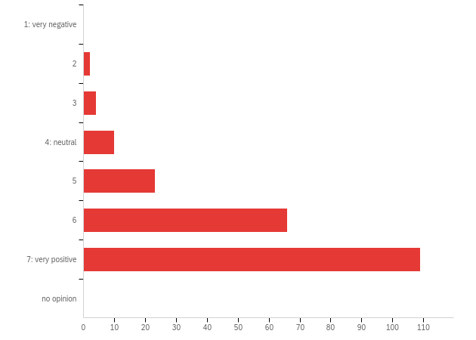

| # | Field | Minimum | Maximum | Mean | Std Deviation | Variance | Count |
| --- | --- | --- | --- | --- | --- | --- | --- |
| 1 | When it comes to overall value, my evaluation is: | 2.00 | 7.00 | 6.25 | .96 | 1.08 | 214 |

| # | Answer | % | Count |
| --- | --- | --- | --- |
| 1 | 1: very negative | 0.00% | 0 |
| 2 | 2 | 0.93% | 2 |
| 3 | 3 | 1.87% | 4 |
| 4 | 4: neutral | 4.67% | 10 |
| 5 | 5 | 10.75% | 23 |
| 6 | 6 | 30.84% | 66 |
| 7 | 7: very positive | 50.93% | 109 |
| 8 | no opinion | 0.00% | 0 |
|  | Total | 100% | 214 |

**Q7b - Additional comments**

| Additional comments |
| --- |
| Fot knowledge ganing very possitive. Also the abiklity to view sessions afterwards because some relevant sessions are done at the same time. |
| Enjoyed the content and the poeple and the organization of the conference. I would however call for more critical sessions, such as the one on constructivist research and SD. |
| Virtual conference makes it accessible ( no travel cost in dollars and time) . Not sure that echo model is quite right - having recordings available is better than the one-off run that you get at an in-person conference. and discussion opportunties after reflection is a good model that is not there at in-persone events. Maybe more thining round this . |
| I'm sure the lower price and zero travel cost was good for participants from developing countries |
| I'm glad I attended! I received as much benefit from past conferences, if not more in the realm of information and resources acquired. |
| Spectacular conference! I believe virtual format increases and facilitates participation! |
| This was my first ISDC and I plan to attend again next year - hopefully in person in Chicago! |
| The online format allows one to attend more sessions, even those scheduled at the same time--a great benefit. |
| Pandemic didn't matter: if the real conference is the same, I suggest to review the involvement and the inclusiveness degrees of participants. |
| Excellent conference! I loved it an learned a lot. |
| It was difficult to organize this conference, and the result is simply very good |
| Bergen pivoted excellently. I felt that this conference is a game-changer. Workshops recorded, echo sessions, live chat, etc. Was amazing. |
| Being able to listen to presentations and discussions on system dynamics for a much lower price than traveling would have cost - great value! For my purposes, being there in -person wasn't critical. For others it might be. |
| There was a lot of content in the program. |
| I find the post-conference access to session recordings very valuable. In the physical conference, I dont have the possibility to catch up with sessions that were interesting, but which I could not attend. |
| I was not expecting that virtual conference will be a huge success but still I really want the conference next year to be the normal one not the new normal. |
| Any single session I attended provided full value, collectively the conference exceeded my expectations. Masterful use of technology to ensure a great learning experience. |
| You should continue a hybrid virtual format in the future too expand inclusion and participation., but simplify the template now developed. |
| I needed more time to watch the sessions I couldn't attend. |
| Under the circumstances, I think the staff did much better that could have been reasonably expected. Creating an IT environment that is accessible to a broad spectrum of users is always a challenge. I think the staff and the vendors to whom conference organizers outsourced did as well or better than could have reasonable been expected. The multi-time zone format and variety of materials being delivered made this a very challenging assignment. I complement the organizers for pulling it off as well as they did. |
| Excellent. Was more accessible than face-to-face because no travel or hotel costs. |
| I am from Brazil, so it would be rather more expensive to participate. The value for money spent is high. |
| Virtual format worked well; in some cases better than traditional live sessions. Content and quality of the work presented still need significant improvement, at all levels including (especially) plenary and parallel sessions. |
| Of course a few things to improve as it's a first, but definitely on the way to efficient immersive hybrid or fully virtual future events |
| surpisingly good alternative during the corona period |
| The longer duration was a positive factor in strengtening the content of the conference |
| I did enjoy the presentations and the workshops |
| I appreciate my SD friends worked brilliantly. But, the conference should be held in real. Many people attended only limited sessions because they were working at their office or classroom at the same time. |
| High |
| all time zone related. Most workshops were impossible to attend especially the ones I wanted to. It is winter here so was not on to participate in the middle of the night in an unheated house (normal for where I live). |
| I think you did the best possible under the circumstances - but I missed the physical presence |
| The savings in time and money of participating virtually made this a great value. My only regret is the loss of some of the social aspects. Even if we go back to in-person sessions next year, we should consider a hybrid format where there's virtual access as well. |
| Great job turning around a conference during COVID! |
| I was able to find, view, and participate in content that was of interest to me. Excellent value for the price. |
| This was my first ISDC, and I'm very glad I attended. I would likely not have been able to attend in Bergen. |
| this was a good conference |
| Thank you so much for making this happen!! Not just as a bad substitute, but exceeding all expectations! |
| I met people I wouldn't have otherwise known and got a lot of good information about SD. well done. |
| Would be great to still be able to access the recordings after Aug 7th |

**Q8 - When it comes to the plenary sessions, my evaluation is:**

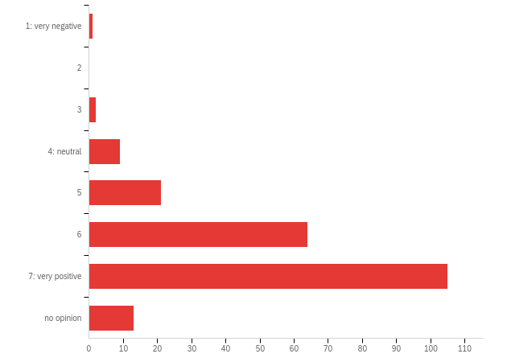

| # | Field | Minimum | Maximum | Mean | Std Deviation | Variance | Count |
| --- | --- | --- | --- | --- | --- | --- | --- |
| 1 | When it comes to the plenary sessions, my evaluation is: | 1.00 | 7.00 | 6.27 | .97 | 1.05 | 215 |

| # | Answer | % | Count |
| --- | --- | --- | --- |
| 1 | 1: very negative | 0.47% | 1 |
| 2 | 2 | 0.00% | 0 |
| 3 | 3 | 0.93% | 2 |
| 4 | 4: neutral | 4.19% | 9 |
| 5 | 5 | 9.77% | 21 |
| 6 | 6 | 29.77% | 64 |
| 7 | 7: very positive | 48.84% | 105 |
| 8 | no opinion | 6.05% | 13 |
|  | Total | 100% | 215 |

**Q9 - When it comes to the parallel sessions, my evaluation is:**

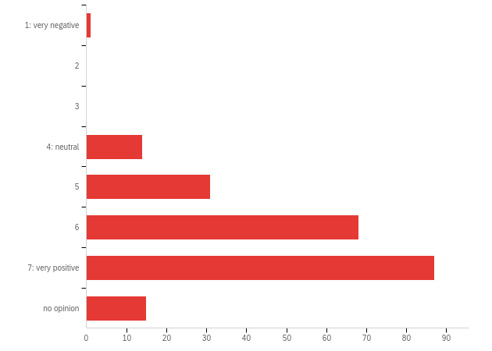

| # | Field | Minimum | Maximum | Mean | Std Deviation | Variance | Count |
| --- | --- | --- | --- | --- | --- | --- | --- |
| 1 | When it comes to the parallel sessions, my evaluation is: | 1.00 | 7.00 | 6.11 | .99 | 1.14 | 216 |

| # | Answer | % | Count |
| --- | --- | --- | --- |
| 1 | 1: very negative | 0.46% | 1 |
| 2 | 2 | 0.00% | 0 |
| 3 | 3 | 0.00% | 0 |
| 4 | 4: neutral | 6.48% | 14 |
| 5 | 5 | 14.35% | 31 |
| 6 | 6 | 31.48% | 68 |
| 7 | 7: very positive | 40.28% | 87 |
| 8 | no opinion | 6.94% | 15 |
|  | Total | 100% | 216 |

**Q10 - When it comes to the work-in-progress (WIP) sessions, my evaluation is:**

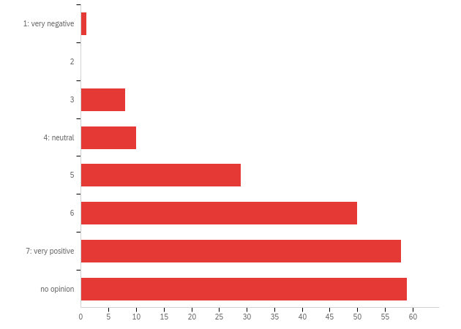

| # | Field | Minimum | Maximum | Mean | Std Deviation | Variance | Count |
| --- | --- | --- | --- | --- | --- | --- | --- |
| 1 | When it comes to the work-in-progress (WIP) sessions, my evaluation is: | 1.00 | 7.00 | 5.87 | 1.20 | 1.93 | 215 |

| # | Answer | % | Count |
| --- | --- | --- | --- |
| 1 | 1: very negative | 0.47% | 1 |
| 2 | 2 | 0.00% | 0 |
| 3 | 3 | 3.72% | 8 |
| 4 | 4: neutral | 4.65% | 10 |
| 5 | 5 | 13.49% | 29 |
| 6 | 6 | 23.26% | 50 |
| 7 | 7: very positive | 26.98% | 58 |
| 8 | no opinion | 27.44% | 59 |
|  | Total | 100% | 215 |

**Q11 - When it comes to the echo sessions, my evaluation is:**

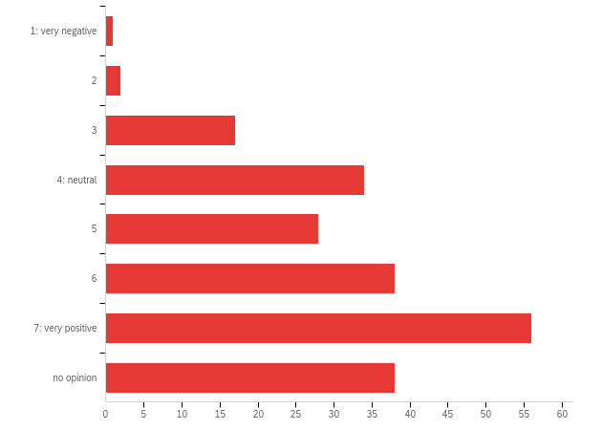

| # | Field | Minimum | Maximum | Mean | Std Deviation | Variance | Count |
| --- | --- | --- | --- | --- | --- | --- | --- |
| 1 | When it comes to the echo sessions, my evaluation is: | 1.00 | 7.00 | 5.45 | 1.41 | 2.70 | 214 |

| # | Answer | % | Count |
| --- | --- | --- | --- |
| 1 | 1: very negative | 0.47% | 1 |
| 2 | 2 | 0.93% | 2 |
| 3 | 3 | 7.94% | 17 |
| 4 | 4: neutral | 15.89% | 34 |
| 5 | 5 | 13.08% | 28 |
| 6 | 6 | 17.76% | 38 |
| 7 | 7: very positive | 26.17% | 56 |
| 8 | no opinion | 17.76% | 38 |
|  | Total | 100% | 214 |

**Q12 - When it comes to the feedback sessions, my evaluation is:**

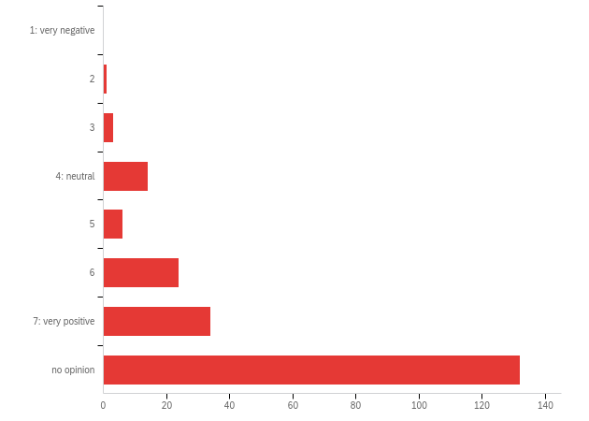

| # | Field | Minimum | Maximum | Mean | Std Deviation | Variance | Count |
| --- | --- | --- | --- | --- | --- | --- | --- |
| 1 | When it comes to the feedback sessions, my evaluation is: | 2.00 | 7.00 | 5.89 | 1.24 | 1.74 | 214 |

| # | Answer | % | Count |
| --- | --- | --- | --- |
| 1 | 1: very negative | 0.00% | 0 |
| 2 | 2 | 0.47% | 1 |
| 3 | 3 | 1.40% | 3 |
| 4 | 4: neutral | 6.54% | 14 |
| 5 | 5 | 2.80% | 6 |
| 6 | 6 | 11.21% | 24 |
| 7 | 7: very positive | 15.89% | 34 |
| 8 | no opinion | 61.68% | 132 |
|  | Total | 100% | 214 |

**Q13 - When it comes to the System Dynamics Colloquium on Sunday, my evaluation is:**

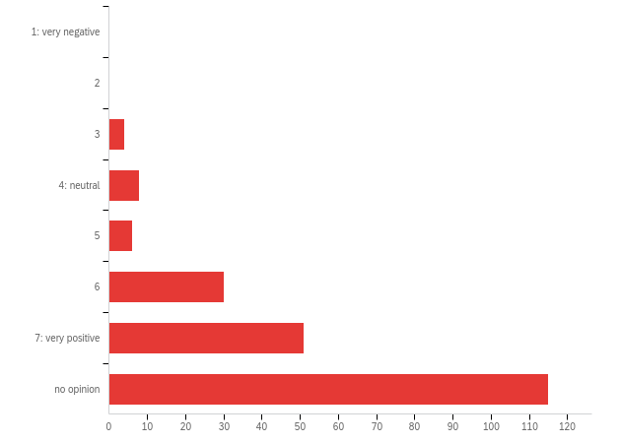

| # | Field | Minimum | Maximum | Mean | Std Deviation | Variance | Count |
| --- | --- | --- | --- | --- | --- | --- | --- |
| 1 | When it comes to the System Dynamics Colloquium on Sunday, my evaluation is: | 3.00 | 7.00 | 6.17 | 1.12 | 1.40 | 214 |

| # | Answer | % | Count |
| --- | --- | --- | --- |
| 1 | 1: very negative | 0.00% | 0 |
| 2 | 2 | 0.00% | 0 |
| 3 | 3 | 1.87% | 4 |
| 4 | 4: neutral | 3.74% | 8 |
| 5 | 5 | 2.80% | 6 |
| 6 | 6 | 14.02% | 30 |
| 7 | 7: very positive | 23.83% | 51 |
| 8 | no opinion | 53.74% | 115 |
|  | Total | 100% | 214 |

**Q14 - When it comes to the poster sessions on Tuesday and Wednesday, my evaluation is:**

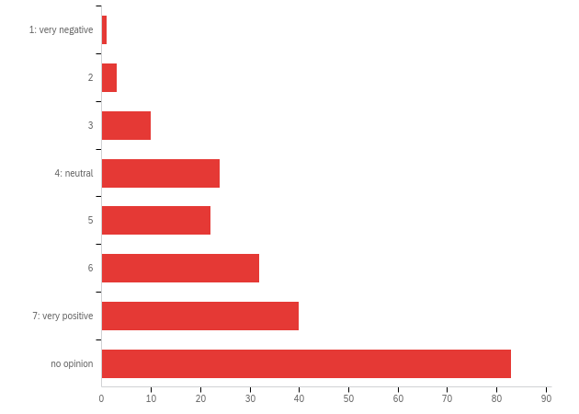

| # | Field | Minimum | Maximum | Mean | Std Deviation | Variance | Count |
| --- | --- | --- | --- | --- | --- | --- | --- |
| 1 | When it comes to the poster sessions on Tuesday and Wednesday, my evaluation is: | 1.00 | 7.00 | 5.50 | 1.37 | 2.87 | 215 |

| # | Answer | % | Count |
| --- | --- | --- | --- |
| 1 | 1: very negative | 0.47% | 1 |
| 2 | 2 | 1.40% | 3 |
| 3 | 3 | 4.65% | 10 |
| 4 | 4: neutral | 11.16% | 24 |
| 5 | 5 | 10.23% | 22 |
| 6 | 6 | 14.88% | 32 |
| 7 | 7: very positive | 18.60% | 40 |
| 8 | no opinion | 38.60% | 83 |
|  | Total | 100% | 215 |

**Q15 - When it comes to the workshops on Thursday and Friday, my evaluation is:**

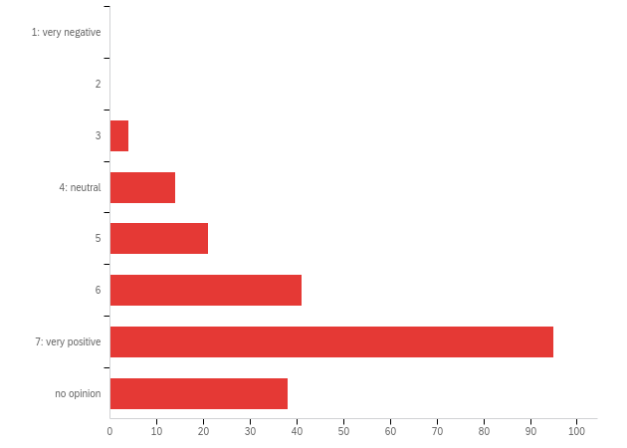

| # | Field | Minimum | Maximum | Mean | Std Deviation | Variance | Count |
| --- | --- | --- | --- | --- | --- | --- | --- |
| 1 | When it comes to the workshops on Thursday and Friday, my evaluation is: | 3.00 | 7.00 | 6.19 | 1.08 | 1.42 | 213 |

| # | Answer | % | Count |
| --- | --- | --- | --- |
| 1 | 1: very negative | 0.00% | 0 |
| 2 | 2 | 0.00% | 0 |
| 3 | 3 | 1.88% | 4 |
| 4 | 4: neutral | 6.57% | 14 |
| 5 | 5 | 9.86% | 21 |
| 6 | 6 | 19.25% | 41 |
| 7 | 7: very positive | 44.60% | 95 |
| 8 | no opinion | 17.84% | 38 |
|  | Total | 100% | 213 |

**Q15b - If you have any comments on session formats, please list them here.**

| If you have any comments on session formats, please list them here. |
| --- |
| Postersession was just a session on my own alone. Not very fruitfull and inspiting |
| The echo sessions were hard to make work. It would have been helpful to make it clear earlier that participants were supposed to have already listened to the videos of the original session, and even knowing that, many of us just didn't have the time to do so. The most effective echo sessions were when the presenter was available to answer questions, but I recognize that's not always practical. Thank you for trying this; I appreciated the opportunity to discuss sessions I'd missed. If the conference is ever virtual again it will be worth thinking about ways to improve the echos. |
| Overall very positive! However, it was a pity that many workshops were parallell as I would have wanted to attend more of them. |
| The participation and exchange during poster sessions was very low unfortunately. At least, in my case, the YouTube link to my poster presentation was visited accomplished of times. |
| I did not understand the difference between echo and feedback sessions. |
| The echos were difficult, because I often didn't have time to rewatch the original session beforehand. Yet, I understand why it was done this way. In retrospect I would have preferred a full repeat of the session to get the most value out -- either replaying the recorded presentation itself or at least a brief synopsis by the presenter. |
| After I got the hang of the Echo session format it became easy to navigate. Finding time to watch the recorded session was sometimes challenging. Probably because I was engaging in so many more sessions than I've ever been able to in the past! (A good thing) |
| this was so much better for me. all the distraction was gone and I could focus only on the content |
| Spectacular conference! I believe virtual format increases and facilitates participation! |
| Can I download the ZOOM recordings? |
| a lot of fun, this was virtual socializing at its best during such a conference |
| Maybe a little bit longer Q/A time span |
| Unfortunately, the echo session I chaired was at 06h30 and therefore nobody attended besides the 2 presenters, the volunteer and myself. |
| I was confused about the echo sessions and didn't know that we had to watch the videos before the session. Some of the original sessions were in the middle of the night for me. When I woke, I would attend the live sessions and didn't allocate enough time to watch the recordings in time for the echo sessions. |
| Seems like the overall design that included different types of sessions worked well. |
| The prominence of the greatest person is not linked to the intensity of the light through which she shows off. |
| Echo sessions were a little hard to manage because timing wise, there wasn't a lot of time to watch the session to be prepared for the echo without missing a live session. However, when managed, I thought it was really nice getting together for additional answers. |
| WIP sessions were good but too quick, even if we consider echo sessions. Poster sessions were not very effective, at least in my opinion (but my 3D app did not work). I enjoyed a lot the plenaries. |
| Too much content that could fit a webinar format. Almost all sessions attended were like demos and not hands-on workshops. |
| Too many plenaries on work already presented at previous SD conferences |
| Posters weren't easy to browse fluidly this year. (Lots of good posters though.) |
| I liked the echo sessions a lot, once I figured out what they were and how to make best use of them (i.e. watch the recorded session first). The roundtables were maybe even better in this format than in-person because of the chat feature -- allowed for more participation. I also was able to participate in workshops, which I don't normally have time for in face-to-face conferences. |
| I think that 6 sessions in 1 hour for WIP sessions were too many. There were rich discussion in between one presentation and the next; and it felt that there was not enough time. Maybe in the future there are less presentations within the hour to take advantage of the discussions. |
| Regarding the format, I think is ok. I loved that everything was recorded so I can digest a lot of material. That is a game changer. |
| It was really nice to have the presentations recorded. I could go back and see sessions that were being presented at the same time, and skip out of sessions if I only wanted to see one without it feeling awkward. It felt like a more productive/valuable time during presentations than it has in the past, where you sit in conference rooms listening to presentations and if certain presentations you don't understand/aren't what you thought they would be/you're not interested, you are still stuck there. You also end up missing out on a lot when everything is live. The other comment I would have about formats is it is not clear what sessions are what. During my first conference, I had no idea what a parallel/WIP/plenary were, and during this conference, I had no idea that we were supposed to watch the recorded videos of the presentation before I went to my first echo. I had no idea what the sponsor office hours were as well, which made me less likely to attend. It also would have been nice to have a description of the sessions and the presenters rather than just the names. The website schedule was a lot to scroll through when you were trying to find sessions, so maybe that could be better organized/more user friendly in the future. |
| Poster sessions filled up fast, so I didn't join in. One said a limit was 25, but over 50 people were signed up. Not sure how that was worked out. Echo's were nice, for being able to talk with the presenters, but I found that watching the recording of the initial session was better quality - more people were in attendance, so the discussion was better. But it is nice to have the ability to attend being in a different time zone - although I don't think I would have liked it from the presenter's perspective - having to do 2 different presentations. |
| Super helpful, just in active simulation workshop it was annoying to have people leave and join your group all the time. |
| The session formats mimicked quite well what happens at normal in-person conferences as did the depth and breadth of content. I felt this overall similarity was a significant achievement by the conference organizing team. I attended numerous plenaries, several parallel sessions, one WIP and one Echo. Interestingly the Echo enabled useful follow-up discussion among the presenters themselves. One criticism: there was too much zoom chat. |
| The Echo sessions suffered from there not being enough time - in the USA anyway - to watch a session before the echo - unless you skipped the live sessions to do so, which defeats the purpose of being there. |
| The biggest challenge was timing of the schedule. In virtual format, I think there was a missed opportunity to spread the conference out over a longer period of time. I think even spacing over two weeks would help accommodate time zone differences and allow for additional time for folks to view recordings/attend sessions in time for additional scheduled time for discussion in echos. |
| Due to the virtual format, we were given the ability to see all the workshops, in our own speed. I also think that people were more interactive due to the virtual scenario. It exceeded by far my expectations. |
| The workshops were wonderful! |
| Scheduling the session during a period that does not coincide with a plenary is important as the workshops usually need more than 90 minutes. |
| some sessions where a bit short with little time for Q&A. |
| The Parallel sessions with six presenters felt rushed, but it worked and I'm glad the presenters had the opportunity to tell us about their work. |
| Please try to do less, that is be more selective and allow more time for interaction. |
| Found attendance at parallels and WIPs was poor and there were few questions or suggestions provided to improve the work. |
| I was not able to access the poster sessions and some other venues that seemed to depend on successful implementation of the "3D app" |
| 1. Plenary Sessions: It will be helpful to turn off chat when a presentation is in progress. Having chats in between is very distracting. 2. Poster Session: (1) In one case, the concerned person was not available on zoom (2) I think some of the posters may have been repeated as parallel sessions. This is OK provided we have time to go through the posters and interact withe authors. 45 minutes for one poster session is bit less. |
| It all went fine, but the dynamics for poster presentation are a bit weird through Zoom (maybe because not many people attended mine). But when we are in a room, you kind of check all the posters and eventually talk to a specific person. |
| In the case of workshops and/or online teaching we are all still exploring how to make nice interactive, easy to follow and yet comprehensive content. So maybe in these type of sessions there is a bit more to improve, but this is not related to the conference, it is a thing to get better at for the entire teaching world :) |
| Roundtables had the best discussions. |
| I did'nt like video presentations in the live sessions |
| I felt the links to worshop materials could have been more identifiable |
| I liked the pre-recorded options. I could get material I missed |
| A feedback to chair of echo session. Thank you to those who quickly recap or asked for elevator pitch before we start. Not everyone has a time to watch the caption. When a chair just remain quiet, it gets really awkward. |
| To collect more various papers, the parallel session submission should change to require only extended abstracts (about 5 pages). |
| Workshops were great, sadly many people who signed up for sessions did not show up, making it awkward for presenters who had prepared for an expected audience...more time to meet up post-workshops could be great (have them earlier in week?) |
| felt that session chairs should enforce WIP timings. Far more time was spent in my session on the presentation which ran for 10 minutes plus before questions, which was unfair on everyone else who had made an effort to compress into the 5 minutes time allowed. |
| Unfortunately, I was not able to participate live in most sessions. Will look at some recordings. I suffered a 2.5 day internet outage during the conference. |
| work in progress requires more time or different format to present the current state of research and challanges.... |
| It was nice o have the list of participants. It would have been nice to have their email addresses. |
| I didn't find the concept of the echo sessions too appealing for some reason. I think I would have gotten just as much as simply watching the recordings of the original presentations. |
| When the programme was announced I thought the Echo sessions were a very important feature, given I live in NZT. In practice I found the recorded sessions easier to manage. |
| The value came from great session chairs and great presentations. Recommend presentation coaching for future conferences either virtual or in person. |
| Echo sessions were excellent for plenary sessions. I liked to hear how established researchers discuss different topics (in oppose to Q&A) which you don't find it in regular presentations. But echo sessions were not necessary for parallel session, and waste of time for WIP (in one WIP echo session that I attended two presenters did not show up). |
| The recordings were very nice! Also, the Echos were a great idea! I appreciate the WIP format, really useful and also interesting to have so man immpressions at once. |
| I might have wished that it were easier to skim the schedule without diving into a session and coming back out multiple times to find sessions I wanted to attend. |
| The WIP are brief |
| posters didn't work as well as they might have in a "live" session |
| Echos were too open in their format; they could have used some guiding questions and more clear info that you need to watch the video BEFORE the echo. Workshops that I attended were too much frontal presentation, too little interaction and practical application; poster session graphical implementation and buttons with contact, video, PDF etc. were perfect - only I wish there'd been some better way to find out where a presenter is, that is, some way to virually "jump" to the presenter when they are online. |
| Wip sessions were too short, there was not room for proving any feedback to the presenters |
| It was really hard to figure out how to get to the poster sessions. Eventually I just gave up. |
| Having WIP sessions at the same time of parallel sessions made it challenging, less interesting to attend WIP sessions. |

**Q16 - How do you rate the overall quality of the presented work?**

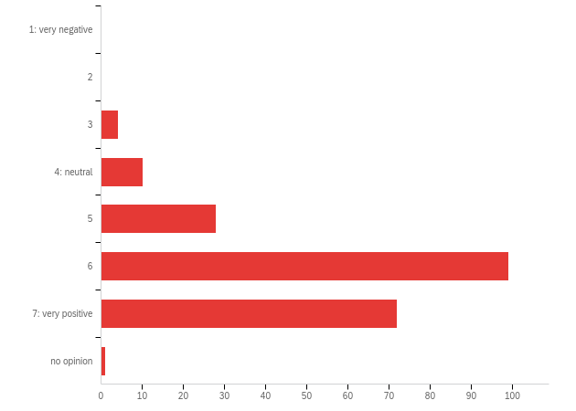

| # | Field | Minimum | Maximum | Mean | Std Deviation | Variance | Count |
| --- | --- | --- | --- | --- | --- | --- | --- |
| 1 | How do you rate the overall quality of the presented work? | 3.00 | 7.00 | 6.06 | 0.91 | 0.84 | 214 |

| # | Answer | % | Count |
| --- | --- | --- | --- |
| 1 | 1: very negative | 0.00% | 0 |
| 2 | 2 | 0.00% | 0 |
| 3 | 3 | 1.87% | 4 |
| 4 | 4: neutral | 4.67% | 10 |
| 5 | 5 | 13.08% | 28 |
| 6 | 6 | 46.26% | 99 |
| 7 | 7: very positive | 33.64% | 72 |
| 8 | no opinion | 0.47% | 1 |
|  | Total | 100% | 214 |

**Q16b - Additional comments**

| Additional comments |
| --- |
| Overall good, but sometimes shifting. I would have called for some more transparency in terms of used assumptions and data when it comes to some presentations. It would be advisable to stress this more in the application for the conference. |
| It would be interesting to be able to access all papers or slides |
| Actually quite a mix of quality. Some parallels were actually WIP and vice versa |
| Lost a lot of time on dealing with the schedule system. Found that I could not go back to the main schedule and often had to log in many times, over and over. |
| My opinion is only partially informed because I am a systems thinker, but not a systems dynamicist. |
| More inclusiveness, less self-congratulation. |
| I agree with some of the commentary from the President's Address that the content was occasionally overtly academic (and sometimes the models were biased towards an answer that would be expected). Overall, I learned an absolute load from all areas that I attended. |
| The plenary sessions were particularly good this year. Good choices! They catered more to broader audiences, and were (mostly) at an appropriate non-technical level for a plenary. |
| Isn't this the same as the content question above? I found the quality range similar to previous conferences. |
| Good, I think there are great ideas. |
| Most speakers were well prepared with effective slide presentations. Time keeping by session chairs was good. The Q&A was often better (in terms of concise questions, well formulated) than in face-to-face. |
| I thought this virtual experience and the many ways you customized for people from all over the world was exceptional! |
| As said before, would be good to see more business oriented work |
| I enjoyed meeting some new people and some emerging contributors. |
| I would like to be able to watch all of sessions after the conference. |
| Hard to generalize. No better or worse that more traditional conferences. |
| Would like to see more from practitioners and more sessions (parallels and plenaries, not just posters or exhibition places) focused around selling SD and addressing needs of clients in commercial applications of SD. |
| It opens the mind to different approaches, to connecting areas. It is an experience! |
| Most of them presented only the GMB & CLD, I would like to see the work on SFD. How about setting the proportion of the presented work into half-half? |
| The echo sessions allowed much more interaction with the audience than is usually the case. That was wonderful. |
| Some were great and Some werepoor. But, it's no problem. This was a conference, not a journal. Collecting many paper and people and showing SD to many is important. |
| I am new to SD though so I defer to the experts, but it was all very interesting to me, rich & cross-disciplinary |
| My eval is based on 3 sessions, so "no opinion" might be more accurate. |
| Gernerally godd, but in the health thread at least, I didn't find the work in parallel sessions as strong as I would have expected. some were more poster or WIP level work. |
| I appreciated the pre-recorded presentations followed by discussion. Very tidy and easy to recap. |
| Some (David Lane, Jorgen Randers, Dr. Schaman, and more) was superb. Some was very good (many of Yaman Barlas' students and more). I found some that appealed to me less, but I moved on before deciding whether it was my interest or their quality that dominated my decision. |
| difficult to judge--I did not have nearly large enough sample. |
| a lot was over my head, but it's good to know there are so many passionate and educated people out there who are interested in SD&gt; |

**Q17 - For our virtual conference, student colloquium posters were displayed in the 3D app and other conference posters were displayed on the conference website. Please indicate which of the following formats you prefer (select one):**

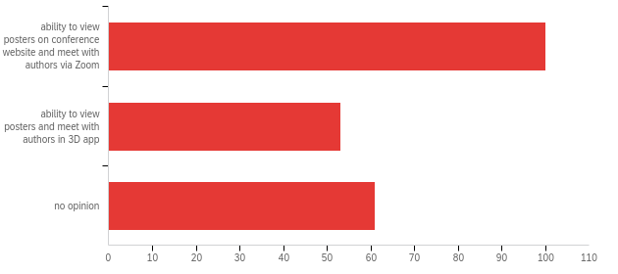

| # | Field | Minimum | Maximum | Mean | Std Deviation | Variance | Count |
| --- | --- | --- | --- | --- | --- | --- | --- |
| 1 | For our virtual conference, student colloquium posters were displayed in the 3D app and other conference posters were displayed on the conference website. Please indicate which of the following formats you prefer (select one): | 1.00 | 5.00 | 2.88 | 1.80 | 3.24 | 214 |

| # | Answer | % | Count |
| --- | --- | --- | --- |
| 1 | ability to view posters on conference website and meet with authors via Zoom | 46.73% | 100 |
| 4 | ability to view posters and meet with authors in 3D app | 24.77% | 53 |
| 5 | no opinion | 28.50% | 61 |
|  | Total | 100% | 214 |

**Q18 - How many years of experience do you have with system dynamics?**

| How many years of experience do you have with system dynamics? |
| --- |
| 8 |
| 11 |
| 3 years part time, mostly on qualitative modelling. |
| 0 |
| I prefer Microsoft Teams in stead of Zoom because of security issues. |
| 5 |
| 40+ |
| 3 |
| 10 |
| 2 |
| 2 |
| First contact was about 20 years ago, although it isn't part of my formal job yet |
| 10 |
| 15 |
| 3 |
| 5 or so |
| 5 |
| 2 |
| 2 |
| 44 |
| I wouldn't really say experience. Rather, I can say that I discovered Systems Dynamics about 10 years ago and since then I have been working to develop myself in this area as well, combining it with Human Resource Management that I teach. |
| 1.5 |
| 10 |
| 6 |
| 18 |
| 1 |
| 2 |
| 8 |
| 1 |
| 28 years |
| 2 |
| 2 |
| 2 |
| 1 1/2 |
| Since 1970. |
| I am a systems thinker, not a systems dynamicist. |
| 3 |
| 10 |
| 1 |
| 4 |
| 5 |
| 30+ |
| almost 20 |
| 15 |
| 27 |
| 3 |
| 3 years |
| a few years |
| 2 |
| 2 |
| 6 |
| 20+ |
| 0.5 |
| 15 |
| 7 years |
| Less than one year |
| 5 |
| 2 |
| 10 |
| 1 |
| 5 |
| 40 |
| 20 |
| More than 40 years. |
| 20+ |
| Too many |
| 3 |
| Five |
| 20 |
| 5 |
| Although I am in contact with SD since 2006, only since 2017 I am learning it in a structured way and applying it in a regular basis |
| 1 |
| 1 |
| 8 |
| 5 |
| 2 |
| 4 |
| 20 |
| 4 years specific |
| 2 |
| 12 |
| 1.5 |
| 10 |
| 10 |
| 2 |
| I shared an office with Dennis Meadows as a graduate student. (55 years) |
| 23 |
| 17 |
| More than 40. |
| 6 |
| 2 |
| 3 |
| 8 |
| 3 |
| 3 |
| 1 |
| 1.5 |
| 6 |
| 25 |
| 8 |
| ~5 (started earlier in my career, but SD is only one tool I use, so on and off) |
| 2 |
| 8 |
| 5 |
| 14 |
| 1.5 years with SD specifically and 5+ years of research in multidisciplinary/interconnected domains (engineering +environment +social) |
| 5 |
| 2 |
| 7 |
| 5 |
| 10 |
| 25 |
| 2 |
| Ca. 1 year |
| 20 |
| 16 |
| 15 |
| 4 |
| 35 |
| 2 years |
| 5 |
| 4 |
| 25 |
| 2 months |
| 13 |
| Beginner |
| 0 with quantitative systems dynamics, 20 years with qualitative systems thinking |
| decades |
| 3 |
| 3 |
| 17 |
| 5 |
| 30 |
| 1 |
| 10 years |
| 4 years |
| 10 |
| 28 |
| 16 years |
| &lt;1 |
| 1 |
| 20 |
| 15 years |
| 25 |
| 9 |
| 2 |
| 2 |
| 4 |
| I never quite figured out how to carry on a good conversation in the 3D world. |
| 20+ |
| 50+ |
| 5 |
| 15 |
| 20 |
| 8 |
| 7 |
| 20 years |
| 19 |
| 0 |
| 10 |
| 10 |
| Neither one was great |
| 34 |
| 8 |
| &gt;35 |
| 20 |
| 7 |
| 3+ |
| 25 |
| 12 |
| 3 |
| 3 |
| hard to say. I used it in the 90s but then haven't used it much until about 3 months ago. |
| 5 |
| 25 |
| 9 |
| 3 |
| 29 |

**Q19 - Have you attended the SD conference before? (Select one)**

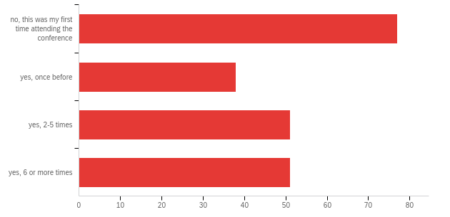

| # | Field | Minimum | Maximum | Mean | Std Deviation | Variance | Count |
| --- | --- | --- | --- | --- | --- | --- | --- |
| 1 | Have you attended the SD conference before? (Select one) | 1.00 | 6.00 | 3.64 | 2.06 | 4.24 | 217 |

| # | Answer | % | Count |
| --- | --- | --- | --- |
| 1 | no, this was my first time attending the conference | 35.48% | 77 |
| 4 | yes, once before | 17.51% | 38 |
| 5 | yes, 2-5 times | 23.50% | 51 |
| 6 | yes, 6 or more times | 23.50% | 51 |
|  | Total | 100% | 217 |

**Q20 - How do you evaluate this year’s virtual format as compared to the traditional face-to-face format?**

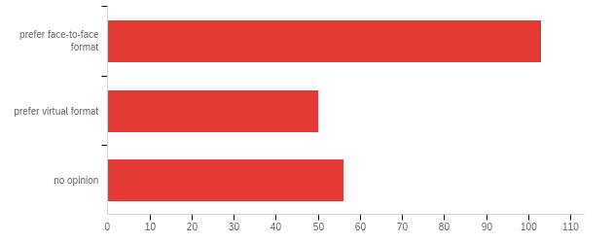

| # | Field | Minimum | Maximum | Mean | Std Deviation | Variance | Count |
| --- | --- | --- | --- | --- | --- | --- | --- |
| 1 | How do you evaluate this year’s virtual format as compared to the traditional face-to-face format? | 1.00 | 5.00 | 2.79 | 1.80 | 3.24 | 209 |

| # | Answer | % | Count |
| --- | --- | --- | --- |
| 1 | prefer face-to-face format | 49.28% | 103 |
| 4 | prefer virtual format | 23.92% | 50 |
| 5 | no opinion | 26.79% | 56 |
|  | Total | 100% | 209 |

**Q21 - Which of the following features, if any, would be worthwhile to continue for future conferences? Please check all that apply.**

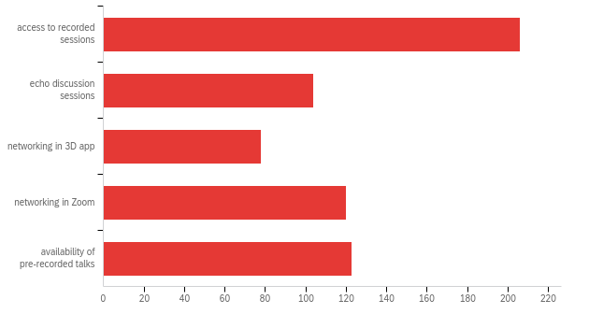

| # | Answer | % | Count |
| --- | --- | --- | --- |
| 1 | access to recorded sessions | 32.65% | 206 |
| 2 | echo discussion sessions | 16.48% | 104 |
| 3 | networking in 3D app | 12.36% | 78 |
| 6 | networking in Zoom | 19.02% | 120 |
| 7 | availability of pre-recorded talks | 19.49% | 123 |
|  | Total | 100% | 631 |

**Q21b - Other (please specify)**

| Other (please specify) |
| --- |
| A hybrid conference: a wider audience, you can participate on line but if you want or are able you can join face-to-face |
| Access to the recorded sessions was nice, but recording would seem inappropriate in a face-to-face conference. One might offer presenters the _option_ to have their presentation recorded, but I would strongly caution against recording the discussion part, for fear of stilting it. |
| In the previous question, I checked, the 'prefer face to face meeting. The best option, I thing is a combination of digital and face tot face. |
| Actually, I prefer a hybrid format combining face-to face and virtual format |
| Format should be both face-to-face and virtual: In Europe I prefer face-to-face, when happening on another continent I prefer virtual format. to reduce CO2-emissions |
| Having recorded sessions and workshops is extremely uselful. I spent the past week viewing things I missed. |
| I'd like to have all of the capabilities, along with in person. I want it all - ha!!! |
| There is no substitute for face-to-face meetings but the conference showed how a range of alternatives can develop, and pointed to ways in which various sub-groups can work together using Zoom. Obviously, climate change gives us pause for thought about the place of international conferences. Perhaps we could have, simultaneously, regional events (Europe , North America probably easiest, not so sure how best to configure Asia and Australasia), with some shared plenaries and / or recordings. But then, one wouldn't travel within Europe (in my case) to spend a lot of time on-line once we got there. Perhaps some cycle of a world conference every four years, and regional events in the years between? I would have been able to travel to Norway from Scotland without flying, and had intended to do that this year. |
| I thought the 3D app was interesting but unnecessary if it adds to the cost of the conference. |
| There may be a large enough segment of people who would attend our conference online if that option was available every year. It would be great to think about how to record every session for online consumption. Maybe screen recording the slides and audio on every laptop in every room would be enough. |
| I could tell that a lot of thought went into how to use the virtual platform. People did really well but some speaker's microphones weren't as good as it was little hard to hear them. Maybe have technical suggestions for speakers in terms of internet bandwidth and microphones? |
| Interactive workshops and demonstrative live modeling sessions. |
| I absolutely LOVED being able to see recorded sessions again especially after the conference. It's been a complete blessing to see things I may have missed or rewatch presentations I didn't understand well. I'd love if we can find a way to have that continue in future conferences. |
| I think having perhaps more unstructured socialising sessions via zoom would be nice. Perhaps setting up zoom rooms with loose topics - e.g. share your experience modelling covid, share your experience doing group model-building, group chat for PhD students: what's it like doing an SD PhD where you are?, making it out on your own - a group chat for new SD consultants, Looking for an SD job: chat with employers and other job seekers, etc. I think that would be a nice way to encourage socializing. Kind of like if you had themed dinner group chats at an in person conference, except it is a scheduled drop-in time. |
| I leave in Europe and I would find the opportunity to attend the Conference online when it is organized in the USA. That would definitely help a lot of scholars to attend without having to travel worldwide. Obviously, I would go in presence every time the conference is organized in Europe. |
| For question about virtual format above: Need another response option. I really liked some features of the virtual conference and would like to see them continue, but I like the social interaction of face-to-face conferences. I don't prefer either exclusively. My preference would be to have some kind of hybrid each year, or maybe alternate virtual and in-person formats in different years. |
| Chat! Do not forget that parallel to the sessions, people have really deep conversations in the chat or share some stuff too! It is not only video, but chat as well, do not forget that! They need to go together. The online directory was phenomenal. It allowed to get the contacts and write the SD professionals |
| Would be useful if recordings could be available longer than just to August 7 |
| pls also record user group meeting. |
| Echo discussions would be useful for people who later watched recordings, but otherwise not for an in-person conference. |
| Specifically, echo sessions that were scheduled in a way to allow participants time to view recordings before the echo. |
| The possibility to share some of the recordings publicly (to promote SD work and SDM-generated insights to the outside world/non SD-community) |
| See comment above about continuing with a hybrid (face to face and virtual combination) in order to add diversity and increase participation. |
| I really liked that you were able to introduce topical work on COVID-19 and the Racism Roundtable. |
| participant profiles |
| Hybrid conference - virtual for posters (especially for those who cannot travel), then in person with recordings available. Full virtual conference every alternate year. |
| The idea of echo session was principally good, but might be an idea to not have the same sessions in parallel in the echo as in the original session. |
| not having to fly |
| Roundtables were great! I liked that the sessions were recorded so that I could catch up on parallel sessions that i missed -- this really added a lot of value to the conference. |
| Keeping the conference online as well as offline. Live presentations can be streamed. That way more people can attend the conference and listen to the talks with out flying. |
| Ability to dial in in real time of course, and a moderator who would take questions from online participants |
| plenary and parallel sessions available in virtual format |
| online access to sessions; including possibility to ask questions via chat |
| we might want to consider offering a comination of in-person presentations that can also be attended remotely |
| Poster session as Zoom |
| I prefer the virtual format because I was able to see more presentations. BUT the social connection is also very important to me, so I'd like to have a way to network/socialize. Although the wide choice of costumes for our avatar, not being able to see the actual face of the person I am talking to was quite uncomfortable (unexpectedly). |
| 3D app looked a little out of date. I remember "Second Life," an online service. |
| More structured opportunities to network, ie games or mini-project opportunities, or perhaps special interest or topic "lounges" or wiki boards |
| I prefer in-person, but I would not have been able to participate at all if this had not been a virtual session (w/out COVID) because of time/expense of travel and timing of the conference. (This week in July I always have 3 conferences I want to attend and usually can do only 1). |
| In the question about preference for virtual vs. face-to-face conference, I selected No Opinion, but really would have wanted to select hybrid of the two. |
| Workshops are for me the most valuable events. |
| The avatars and UI were a little hard to get used to, as well as running around a field to get places. With some navigational improvements, I'd be happy with that. |
| Echo sessions ONLY for plenary... |
| It was great to see the participants list and their emails from the first day. |
| implement a "chat" during live sessions |
| The question before only allows me to prefer either face2face or virtual conf. Neither is the case; I'd love to have them face2face as usual alternating in different continents AND have some virtual aspect ALWAYS; or/and every third year alternate with virtual perhaps. |
| While i PREFER face-to-face conferences, this one was pretty good. Kudos to whoever designed the entire technology approach. I particularly liked how the system translated the schedule into one's own time zone. |
| Since folks are all over the world and everybody's trying to balance this with home-life demands, I think it would be nice to just have things repeating whenever. For folks in the central US there were long blocks of time in the our late afternoon and evening when nothing was happening, but I would have participated in stuff then. Although I guess maybe that would be harder on presenters. |

**Q22 - What do you value most about participating in the conference?**

| What do you value most about participating in the conference? |
| --- |
| Getting new insights, discover the wide field of SD |
| The opportunity to hear about applications of SD in fields wider than my own work. The opportunity to think more about why SD interests me. |
| meeting colleagues |
| To get an idea of current developments and work in the field, get inspiration and contacts! |
| Workshops |
| Ability to access more sessions than i normally would have in person due to recordings. The free flowing discussion in a small group in paralok session echos were nice |
| Hearing about and seeing what others are doing. Networking. |
| The effort of the organizers to creating a great platform for the exchange one SD and your own work with others. |
| access to wide range of perspectives on SD, to research and WIP. Virtual format makes it accessible in a way the travel time and dollar cost make difficult. Maybe have virtual every 2nd or 3rd year as it is good to meet in person as well. |
| All I got to learn about the SD and System Thinking |
| Good references, ideas and people |
| Inspiration! (content and meeting people) |
| Content and contact with others |
| Learning about the breadth of work happening in the SD Society and with system dynamics. Meeting new people, networking, and getting feedback about how to improve my own work. |
| Learning from others and finding out about available resources to support my work. Also, meeting with other attendees and presenters to learn from them and learn about their research. Participating in the Model Building Workshop is a personal favorite aspect of the conference. And, under normal circumstance, I enjoy traveling. |
| the whole experience of an online conference. it was my first one and it was great. |
| Virtual participation and access to recorded sessions. |
| most sessions were very interesting and I wanted to go to all of them ;) |
| Face to face interaction |
| gathered knowledge, confidence, and networking |
| Meeting interesting people, hearing about work both related and foreign to my field. |
| Hearing from people with a lot of experience teaching SD, as well as seeing how students are incorporating SD into a variety of projects. |
| Being able to listen to great plenary talks and to attend great workshops. |
| Connecting with old friends. But would the virtual events have worked so well if I did not already know the faces and voices? |
| Meeting new people, reconnecting with friends, learning new skills and tools via the workshops and learning about how others apply SD in their work. |
| Meeting the SD folks |
| Networking |
| Catching up with old friends, meeting new people, learning about new work and new developments in the field |
| I would not have been able to participate do to time and financial restrictions if it were not for the virtual format. I learned a lot and made some very helpful contacts. |
| Concrete way to present the topics |
| really learning; hands on experience |
| Getting insight in new topics and models. |
| Gained new knowledge snout developments in loop dominance snd that it is available in one of the simulation programs that I have, but have not used as much as another simulation language, |
| obtain an overview of what is going on in the field |
| 1) seeing what SD community is working on, 2) seeing conclusions they are drawing from their work on important challenges, 3) understanding the evolution of the methodology and its power |
| The possibility to compare different modelers' research works and approach to different or same issues. |
| I joined this year in order to see if this was the right direction for me in my career and I left learning how you can use modeling in all sorts of aspects. At the banquet I was able to connect with multiple people and it was so educational and inspiring. Great conference. |
| 100% it's meeting other SD practitioners. The SD conference is a great networking opportunity. |
| Meeting people and chatting about their work |
| Meeting people and getting to know relevant work and research in the field |
| Meeting people. Learning about new things. |
| Social interaction; access to NEW work in the field |
| Mostly interacting with people, which was actually better in some ways this time, and learning about the variety of ways people are applying SD. |
| Low carbon footprint, ability to meet people |
| Attending zoom presentations and 3D world socializing. |
| Refresh old connections and make new ones |
| State of the art knowledge and networking with practitioners in the relevant fields and like-minded people |
| I guess the closeness of the hosts. I think we had several moments in the Zoom meetings where we were able to talk and network, and get some |
| The ability to ask questions and engage with presenters which was more possible this year than previous years. |
| Having recorded sessions for more than two weeks and chances to communicate with senior SD modelers and junior modelers |
| networking with other researchers |
| The range of ideas and work going on around the world. The diversity of participants. |
| Networking |
| The opportunity to chair a WIP session. This was my first such experience and I thank the organisers for choosing me for the role. |
| The networking with old and new colleagues and the connection with has been discussed and researched in the field. |
| Getting to hear what else is happening in the field |
| Seeing other's research, viewpoints from experts to help me learn SD better. |
| The recorded sessions. Enjoyed it so much, especially when you want to soak in everything and do not have to make trade-offs in terms of which sessions you are attending. Also the fact that it was online and allowed to save significant travel expenses was a big benefit. Socializing in person would have been nice but especially for people like me (student), joining the company in-person might have not been able otherwise in terms of money and ecological considerations. For climate reasons, I try to avoid flights as much as possible. |
| Meeting like minded people |
| New comer acceptability |
| Opportunity to interact with colleagues and catch up on recent work |
| exchange ideas and insights. learning something new. meet people in the field. |
| The opportunity to hear about new developments in the field -even though I'm wary of the trend toward computationally intensive and data-driven modeling methods. |
| The growing diversity of the topics and the wide range of expertise levels of the participants and presenters. The conference feels like it is becoming more about learning together versus a showcase focusing on the "experts." I prefer a learning environment that includes people at all levels ..... including the experts of course. Yet, I appreciate when experts are also open to learning, and modeling that for others. |
| Meeting people/networking. |
| content and collaborative spirit |
| Networking, learning new content and new applications of SD thinking/modeling. |
| Plenary |
| Connection to others |
| Learning from others; identifying new trends; the workshops were great this year. |
| The things that I learn |
| Keeping up-to-date with the most recent SD work and developments in the field. Skill and knowledge-building and sharing within the workshops. Networking with and learning from experienced SD practitioners. Peer-group work. Inspiration to continue working on certain topics. |
| meeting people and networking, workshops, presenting my work and receiving feedback |
| Connecting with other system dynamicists. |
| Networking |
| good quality presentations |
| Enlarging my perception of SD possibilites; Meeting people, meeting comapnies |
| Seeking feed back from seniors, looking collaboration with the like minded and socializing |
| Access to cutting edge work. Connections with colleagues. |
| Exposure to SD applications / methodology |
| Transfer of knowledge, access to research works from researchers around the world |
| I could not have attended in person, so the virtual format made it accessible. The value of attending, versus merely reading the papers later in the conference record, is immeasurable. |
| Having a chance for feedback on my current work. |
| Watching the videos of the sessions that I couldn't attend live. |
| The Colloquium and opportunity to serve as an "angel advisor" , Birgit's Presidential Address. The concluding plenaries on the state. A parallel presentation on community building organized by faculty of the Brown School. |
| SD energy and update skill and knowledge |
| Exposure to new fields of application of System Dynamics |
| Learning more about SD |
| People - catching up with old friends, uni colleagues, meeting the legends (Moxnes, Barlas, Sterman, etc.), making new connections |
| the opportunity for learning |
| The discussions about the SD approach, all the pathways it enables discussing. You will meet many different perspectives. So rich! |
| learning about other work different my own and meeting other SD practitioners |
| Learning about others' modeling. Seeing colleagues. |
| inspiration, feedback, usually the conference fills me with the energy for future work |
| Knowing people and their work |
| Broaden my methodological knowledge and learn from other applications |
| Networking |
| see the overall development of the field through plenary sessions |
| Be part of a growing, forward-looking society that values inclusion and multidisciplinary values |
| learning from others' experience and about the state-of-the-art in the field |
| Seeing other people's work. Getting a sense of the larger community. |
| Listening to what others are doing and learning new things |
| The parallel sessions online make it easy to focus on the topic and to participate in the discussions |
| Workshops and exchanges |
| For me it is the ability to socialise and network, of which there was little chance this year |
| I think the Conference is very rich. I am new in the field and I learned a lot about system dynamics. |
| Not having to travel |
| Workshops |
| Insights in how experienced people in SD are adressing various problems. |
| feedback on ideas and get to know what others are working on (what are "hot topics") |
| I need not travel |
| Being exposed to the broad application of SD around the world. |
| workshops |
| As a newcomer it was most beneficial to be able to speak with other first-timers and experienced people. I made one or two valuable contacts |
| I found. the chat feature in Zoom extremely valuable (if a little distracting at times) |
| seeing interetsing work, meeting people |
| sensing the general interest of the community |
| Participate without paying for hotel and air ticket |
| Learning from the experts |
| A chance to discuss people’s work ie poster or echosession rather than just listen to a presentation. |
| Hearing great speakers. Reconnecting with colleagues. Increasing my understanding of SD and its applications. |
| Teachings and Networking |
| getting feedback on my presentation. Listening to great works. |
| access to presentations or recorded sessions as many as possible |
| Learning new things |
| To find interesting papers, to meet SD friends and colleagues, and to get the latest information about software and techniques. |
| Learn a lot |
| As a beginner, lots of learning opportunities. The feedback sessions are so valuable for a newcomer to learn from, excellent format. Being able to access sessions afterward and watch as many as one likes is fantastic. Being able to participate even if not in person! |
| meeting people - which I didn't really get to do apart from a few people I was in Q&A sessions with |
| It was fantastic to be able to connect with participants around the world across different time zones. There is an earnestness that SD practitioners bring that was evident in this virtual conference. |
| Great to get inspired seeing new and continuing work |
| Meeting people, socialising. there is no substitute for face to face |
| Seeing the progress of work on important topics in society/world (climate change, social issues, health, etc.) and learning a little more about system dynamics every time I interact with others in the field. |
| access to great scholars |
| Networking |
| That it was virtual! Had it not been virtual I wouldn't have been there. |
| Learning and networking. |
| Learning about what other people are doing with SD, especially in areas I'm interested in such as health care and environment. |
| The reviews e.g. Lane, Randers and the work in progress e.g. upcoming content of Cavana et. al. |
| new information and connections. |
| Opportunity to see SD applications and innovative approaches. New initiatives that are making the field more supportive toward members' interests. Sense of community created through joint leadership of the senior members. |
| Networking and learning new ideas and applications of SD. |
| The ability to "see" friends even thought the conference was virtual. |
| Helpful open feedback, the workshops, the network opportunitier, a great community with so many different and motivated people. |
| exchange with others |
| Learning from experts |
| Communicating with exerts of the field. |
| networking and learning about current research |
| New ideas, new contacts, testing one's own thinking. |
| The chance to know the first system dynamicist |
| The community aspect above all else - they carry the conference both face to face and virtually, and sometimes the most valuable part is not the greatest new modeling work, but the time for discourse beyond, on e.g. epistemological matters of modeling, or support in professional challenges. |
| Seeing all the good work. I also liked being able to ask questions at parallel sessions and even to some extent at plenaries. |
| Networking |
| Professional knowledge sharing |
| Getting information about SD works, about how my tools (Stella) can be used to do it, and access to some really bright minds involved in SD. |
| Seeing what work others are doing, meeting people, getting a chance to connect and catch up with colleagues, opportunity to present my work. |
| The high quality of the plenary and parallel talks. |
| Vast array of topics |

**Q23 - What was the best thing that happened to you at the conference?**

| What was the best thing that happened to you at the conference? |
| --- |
| The photo of our workshop which was shown in the closing session |
| I enjoyed meeting people who got me to think about how Lean/Six Sigma and SD are linked, which is the passion which originally got me into SD. So I learned more about an old interest. I also really liked the discussion between Jorgen Randers and David Lane about climate change and authoritarian regimes in the late plenary on Wednesday. |
| creating possible new cooperations with colleagues |
| Getting some interesting contacts with whom I hope to continues discussions and explore potentials to collaboration. |
| surprisingly: meeting people! I connected with various people during the conference and made meaningful connections. |
| Meeting with peers |
| Good discussion and Q &A on my parallel presentation and echo in the main session and echo |
| Unfortunately I was involved in running a workshop at the same time the conference was going on and was unable to attend many of the sessions and workshops I had hoped to participate in. It was frustrating not to be able to contact others directly and to ask questions of their work. The best thing for me was to have session recordings available. I have been able to do some networking as a result. |
| I met some people virtually that I knew from previous SD workshops and the SD German Chapter. |
| access to recorded sessions |
| Learn new tools like Stella and Kumu |
| Due to time zone, it was hard to accomplish live presentations, but I could fit recorded presentations on my own schedule |
| being able to watch sessions 2 weeks later when I was already on holiday and my boss could not call me to work |
| Got excellent input into my own work and how to improve it. Also met some people I will be following up with to learn more about their research and potential collaborators in future. While in-person is usually best, I felt I met more people in the virtual setting and talking to people was easier (especially to more senior people). |
| I learned a lot and gathered a lot of resources useful for improving a policy simulation modeling class I'm teaching this semester. I enjoyed so many different aspects - and, was even able to connect with some of my research colleagues from other institutions in the 3-D virtual environment. Wonderful experience! |
| Had a great plenary presentation and a very nice peer mentoring roundtable |
| Virtual participation and access to recorded sessions. |
| work shops, and easy to ask questions. The plenary with Jørgen Randers and Richardson were also brilliant. |
| Zoom chat - it was nice to make comments that way, and to interact privately with friends |
| You could call me old fashioned, but the simple fact that I was somehow in the neighborhood of some famous scholars such as John Sterman, David Lane, Diana Fisher, and others, it was for me a dream come true. Maybe next time I will have also the courage to talk with them as well. |
| I loved the workshop on M-tools, as it is quite useful for my own work, and many of the other participants were thinking of using it in similar ways. I also loved the EN-ROADS Climate Negotiation Simulation because it was so participatory. |
| Coming across with friends in the 3D environment. |
| Meeting someone who works 50 miles away from me? |
| Receiving great feedback/questions from those that attended my talk. And receiving detailed feedback from one of my Angel Advisors at the SD Colloquium. |
| David Lane's presentation |
| Meeting top SD modelers/teachers |
| I really enjoyed the isee workshop on the new feedback loop dominance model analysis tool. |
| Meeting people who have vonuteered to help me develop my skills. |
| Possibility to attend simultaneous conferences |
| I really enjoyed the workshops and getting some more practical experience |
| 1. Summer School 2. a very impressing lecture of Prof. Jorgen Randers |
| Seeing the good work my former students and colleagues.. |
| the ability to move quickly among parallells |
| Conversation with a young journalist (first time attendee) in 3D space on Sunday, combined with the fun of learning how to show up in and navigate the 3D space. |
| Re-evaluate SD in a more professional way. |
| I watched presentations from different professors in different unis I've considered applying to. I also thought the COVID work was exceptional. Oh! The workshops were so great! I learned a ton, and I loved the class structure. |
| I'm not sure there was a best thing. It was just overall a nice experience. I like chatting with other SD people. I like going to the conference and people recognizing my name and wanting to chat. the SD conference is the one time per year where I get to be with "my people" |
| Talking about research during a so difficult period. Refreshing. |
| 3D student poster sessions. Talking and dancing with friends in 3D. Catching up on recorded sessions. |
| Saw (but found it difficult to interact with) some old friends |
| Being able to watch recorded sessions, participating in echo sessions, participating in roundtables |
| Received peer feedback |
| Learned new things from the presentations. |
| I could konw some nice tips about modeling and evaluating models. |
| The feedback and interest in the work i have been done was very positive and exceeded my expectations for an online event. |
| That we continued the tradition of addressing the world's grand challenges and of relentless learning |
| Hearing thanks to the Zoom and chat functionality that there are people interested in the field I am on. And learned about new oppportunities on how to |
| Becoming connected to so many more experts in the field and learning from them. |
| Having recorded sessions for more than two weeks and chances to know people who are interested in SD around the world |
| I attended webinars that were very relevant to my work |
| The fact that I had more attendes to my presentation than I ever had in a face-to-face format |
| Same as above. |
| Reconnect with old colleagues and meet new ones. The experience was absolutely fantastic and inspiring! |
| Presenting |
| attending the summer school and the workshops |
| Follow-up zoom sessions with colleagues |
| ability to view all sessions I was interested in. |
| The intense discussion among presenters in a WIP session. |
| Hard to pick one-- great sessions with multiple take-aways |
| Horsing around in the 3D world. |
| getting to know people and new insights |
| To meet Diana Fisher at her workshop. |
| Jorgen Randers |
| Engaging discussions at roundtables |
| I didn´t have one best thing. I enjoyed very much most of the things. I enjoyed listening to Geroge Richardson, I was very inspired by David Lane but I also loved the workshops from Friday... |
| Learning about SDMDoc |
| collaboration |
| GMB workshop, strengthening the GMB-related community of practice, |
| meeting new people |
| Seeing more compatriots being able to participate |
| SIG meeting |
| the collegial atmosphere in sessions |
| Access to a big amount of good quality papers. Meeting people |
| Met some amazing System Dynamists and formation of peer mentoring group. |
| I saw the future of virtual conferences. I was inspired to dig back into my own SD work. |
| Engaging with students at the colloquium |
| The President's Address. I was always glad to be a member of the SDS, but after Brigit's address I am so proud to associated with this incredible organization. |
| Hearing David Lane's presentation at the beginning and a chance to work with Brad Morrison. |
| Made many helpful contacts to do followup work with. |
| Birgit's Presidential address. The efforts of Help staff to make my life easier. |
| Relaxing environment at home attending the conference |
| Learnt about many areas of SD application |
| Opportunity to learn about SD |
| Reconciled a fractured relationship with a friend after a chance meeting in the 3D avatar world. |
| all was excellent, but asisting a talk by prof. Jurgen Randers was also fantastic because I read the limits in 2005 and it is my favourite book. |
| I am finishing my PhD so I could think better on how to connect the parts of my work. I also used what I saw as reference for a postdoc project I will submit. |
| Was able to hear more about great the work my former colleagues are doing |
| The workshops |
| Surprisingly, the echo session for our WIP was better the regular session. Better discussion |
| We got our own booth and people recognizing us |
| Got good advice on methodological challenges |
| Feedback sessions |
| meeting friends |
| I think it was overall very fun to explore the 3D world and trying to make contact with other people figuring out the same things. Otherwise I liked very much most of the content of the plenary sessions and was happy to listen to/meet people from many areas |
| insightful and stimulating application of SD / ST in some documents that I never thought about |
| Made some new connections with people working on similar topics. |
| Attending talks of people I admire. |
| Possibility to share experiences + attending workshops |
| Catching up with a couple of old friends (on Skype) |
| During the my echo session, I had the opportunity to get more feedback on my paper. |
| Workshops |
| The workshops were very good and helped me a lot in my work. |
| to meet, in an outbreak session, a young researcher from abroad, who knew my published work in detail |
| Presenting in a parallel session |
| some of the plenaries |
| Meeting Len! |
| I was able to attend because it was virtual, learn from and engage with participants. |
| learning a tiny feature of Vensim that I did not know was available; also getting to know the other presenters at the echo sessions |
| To be able to reach all the sessions |
| Can join and watch record of many workshops that run parallel |
| Listening to David Lane |
| Exposure to how to use a program in workshops |
| Having a significantly larger number of participants in my two workshops. I felt I was able to share my experience/expertise with more people. |
| been able to listen and see other people's work. Learning new ways of modeling |
| being able to listen to recorded sessions. |
| access to recorded sessions |
| Organized virtual conference as I ever witnessed |
| To get the latest knowledge of modeling. |
| The echo session was a good idea because speakers rethought their presentations and gave us a deeper level of discussion. |
| Get a lot of knowledge |
| Being able to participate in workshops and the Summer School sessions, sometimes in very small groups with time for interaction. |
| a couple of good connections |
| I thoroughly enjoyed the plenaries - even though we couldn't see each other, the group chat reinforced the shared experience. |
| Inspiration that we can make this work with next to no carbon footprint |
| I survived! |
| Attended an interesting echo session and had a great conversation in chat while different Q&A were also covered verbally. A cool thing you can do virtually that you can't do (at least synchronously) in person. |
| I received so much feedback I never imagined. the connections I made through Rod are priceless |
| Learned about a lot of new research currently being carried out |
| Connected with dozens of people I'd not met before. It was awesome! |
| Meeting friends in 3D space. |
| Getting most of the learning without the time and expense of traveling to Bergen. |
| Ventity |
| Met some folks that might do work with me and be a useful network. |
| Sense of optimism and commitment for new challenges! |
| Seeing new work presented by the authors. |
| I got very nice responde to my WiP presentation and helpful input and good questions. I made so many new contacts. As first time participand this were both very valuable things! |
| was able to attend time colliding sessions as they were recorded |
| Connecting with more volunteers |
| I made a handful of friends from beginners to some of the biggest names. |
| nothing |
| Stimulating intellectual exchanges with a few interesting people. |
| Presenting my work and realizing that it had an impact |
| To gain a wholly new perspective on something in conversations with colleagues that I could not have found anywhere outside the SD world. |
| Connecting with colleagues during my poster session. |
| Talking to many "big names" |
| Opportunity to meet some senior system dynamists |
| I found out how to build a main chain for e-commerce |
| One of my male colleagues unintentionally presented my ideas as his during a Q&A session and when I asked him to please credit me he did a very good job of being accountable. |
| The learning achieved. |
| ENroads workshop |
| I liked going to plenaries and parallel sessions over Zoom because I could move around during them! |
| and learned a lot |

**Q24 - What was the worst thing that happened to you at the conference?**

| What was the worst thing that happened to you at the conference? |
| --- |
| Doing a poster session on my own for myself alone. (no feeling of any connecting; feeling lost) |
| Feeling pressure to keep my Zoom video on. I hated the feeling of being not only observed, but recorded at length, in my own home. It was also hard to keep up the momentum for multiple long days at home, especially when it is hot (and sustained video use makes the room even hotter). In a face-to-face conference, the excitement is easier to sustain and there is more physical movement to break things up. I appreciated the opportunity to attend this year when virtual was really the only reasonable option, but I won't be attending future ISDCs if they're virtual. |
| too much screentime |
| Not to have time to watch all of the recorded sessions I liked to see after the end of the conference. |
| I gave a workshop for 50+ people, and although I am grateful for the many sign-ups, this was quite difficult to manage online. |
| Poster session |
| No new contacts made as I find it difficult to network |
| See above. |
| Unfortunately, very low participation during my two poster sessions. However, around 10 people watched my YouTube poster presentation. |
| I got very confused with initial plan to 'attend' echo sessions and had not factored in need to access recordings. It turned out to be better to wait to post-conference week to access these or to attend in real time and adjust work schedule at + 12 hours |
| Not being able to attend all events as I wanted because of the time zone and my work |
| Unfortunately, I had problems with my computer... and watched the records later, but I cound't see everything I'd like to see, because I in remtoe work with several commitments. I' would like to have more little more time to see the rest.. |
| 3D-world not working properly (people could not hear me), had to log out and in again |
| Struggling with the 3 D app. |
| Technical glitches in the 3d space, and it ended up being really hard to keep up with things across the time zones. |
| I missed a couple of sessions because I was looking at the wrong conference schedule (not logged in so not my time zone, after all). |
| I had zero beers this conference... |
| More time to review recorded sessions. |
| no sit-down dinners ;) |
| Planning of SIG and Chapter meetings outside of the conference week. In addition, this was poorly communicated |
| The 3D was a disappointment. Audio glitches when I tried it on Sunday - and I never came back. |
| IT issues and bad connection |
| I went to one Echo session where no one (or very few of us) had had a chance to watch the presentations. We were honest, but the host did not know what to do - I would have asked the authors to give a two-minute summary of their talks as the basis for some discussion. Instead there was a lot of silence... I ended up leaving. |
| Presenting in a parallel session, I shared the wrong screen (Powerpoint normal view, when it should have been slideshow) and nobody corrected me. |
| Not having anyone besides the presenters and the volunteer join the echo session I chaired. |
| It wasn't that bad, but the technical difficulties undermined the opening session of the conference and that was a bad signal at the very start. That was the only time I observed/experienced any major technical trouble during the conference, so grea to see that problem was resolved. |
| Smashing into things with my 3D avatar because I could not figure out how to jump! |
| Because of my OS I didn't enjoyed the 3D app :( |
| I went to a panel in which no speakers were there and the moderator read the abstracts and then expected a discussion. I think the moderator tried (not his fault) but no one was prepared to talk about papers they hadn't read. |
| - |
| . Having to go out and back into the confrremv Having to.leave the the conference and getting back in to use the schedule. |
| the technical breakdown in the opening plenary |
| Offering ideas in one of the echo sessions and having them verbally judged as unhelpful rather than considered in a spirit of openness and inquiry by a couple of other participants (not the session leader). |
| To discover that, in a virtual environment, previously-established human relations have always been meaningless. Sad hypocrisy. |
| Nothing! |
| Presenting at 2:30am (not anyone's fault.. except perhaps COVID), and not getting to see Norway! |
| I expected to meet people. The online format worked but was a bit fatiguing. The 3D app did not work and I subsequently did not exploit all the opportunities at disposal. |
| Missed seeing some other folks to catch up by bumping through them in hallways. |
| Couldn't access 3d world for substantial portion of the conference |
| Nothing really, took a little while to get up to speed with the format, got a little lost in the 3d app, overall it was great. |
| Difficulty communicating with an author on Zoom (English barrier?) |
| The 3D world stopped on Wednesday. |
| I could not catch up some discussion (because of my English skill). |
| Session chair used an outdated version of my WIP ppt, instead of the current one which was online for days. |
| Lost opportunities to see old and new friends |
| No real issues presented |
| The multiple times when I tried to have a conversation in the 3D world but either the other person can't hear me or I can't hear them. |
| No |
| Getting lost in the 3D poster field for awhile:) I did a marathon to get out of it....but had fun. |
| I fact that I had to sit in front of my computer the whole day |
| I was unable to attend several sessions due to a family health emergency. The session chaired by me was also from my car in the hospital. |
| Choose what session to attend! =) |
| Presenting and been recorded and having internet issues |
| Getting used and catching up with the various time zones |
| missed user group meetings. |
| Feeling socially inept as an avatar - though I can imagine a better 3-D experience as this technology matures and as I acquire more expertise with avatar controls. |
| Missing things because of time zones-- but that was mostly me and balancing my work schedule with conference schedule. It is hard to manage both and this happens when conferences are virtual. |
| Not being able to see recordings before echo sessions and not hearing people or not being heard in the 3D world. |
| getting too tired to absorb everything |
| nothing. |
| Failure of my 3D Tuesday (banquet) |
| Missing out on sessions because of timing |
| Trying to find sessions. The only not so good thing was searching for something |
| When the 3D world got shut off |
| Took a very long time to understand how the 3D experience works, and then it ended before I got the chance to get a full understanding of it. |
| missing an important session |
| No opinion |
| one parallel presentation was clearly below any SD standards |
| I could not attend everything I wanted (because of external reasons) |
| Conference was very well designed |
| Staying up late to attend live sessions! |
| 12am (local time) work shop on Thursday morning - so early! I would have been better rested except we decided to watch Comet NEOWISE until 11pm. |
| Several serious breakdowns in connection, maybe due to my limited internet capacity away from my office. |
| Not many questions or suggestions after presentations especially the WIPs sessions. |
| My inability to take advantage of material that was only available the "3D App" |
| Technical difficulty |
| Not being able to talk in the 3D world |
| Nothing bad happened. All good. |
| only great things! Excellent work |
| I was a bit frustrated that a few people attended my poster session. |
| was criticized for my chairing |
| A tech fail during a session. My computer froze while I was presenting. |
| Emails - the quantity was quite a big I would say |
| No one could come for the poster echo session (2 am my time) and then missing a zoom office hour - both due to technical problems |
| Felt I asked a stupid question in a plenary |
| Not meeting with other people in person |
| staying up late for echo sessions |
| Having a virtual conference made it more hectic/dense, because I had a few normal work meetings in addition, and because I was trying to catch up with everything of interest with recorded sessions, so likely more dense than a traditional event (once again, this is the case for the general work environment now, not just related to the conference). |
| missed a few sessions due to too many options ;) |
| Nothing bad happened to me |
| Only authors showed up at the echo.. however it turned into a very nice conversation among authors :-) |
| nothing |
| Having my session chair miscount my time, giving me 5:30 minutes less than my time and ruining my presentation. |
| I tried to participate on the poster sessions during the Colloquium on Sunday, but the audio was not good. I could hear a lot of people talking at the same time. In the end, I was barely able to watch poster presentations. |
| na |
| The 3D App was not usable due to my ols MacBook. |
| some small handling Problems with the software |
| Not as much feedback from participants as I had hoped |
| echo session with only 1 participant |
| I had to rush to the dentist during my last workshop - but am working through the recording. |
| I was not prepared in an echo session with my presentation to answer a question (wrong computer) and could not get it to download from the conf website (solved by asking someone else in the room to download it and present it for me) embarrasing |
| Time difference |
| Having a deaf and mute 3D avatar during the “banquet” |
| I hit R accidentally and was bounced out mid conversation |
| Not being able to socialize with other participants. The 3-D app using avatars was a good idea, theoretically, but I want to SEE the people I would socialize with. |
| Time zone |
| I wish we could visit Bergen. |
| Usage of all formats did not communication well |
| I didn't make more new friends than usual. |
| It was difficult to attend many sessions because of the time difference. |
| Not prepared for my presentation |
| Running out of time : ) (and still being too new and shy to engage all I'd like to...so looking forward to next time! :) |
| not being able to attend most of the colloquium or workshopswhich is where I was anticipating most of the value |
| As session chair, it was hard to share screen for a presenter who had technical difficulties, and I therefore didn't manage the time well. |
| avatar sickness =) |
| Stress, both before and during. |
| Lost my internet (complete outage) for 2.5 days of the conference :(. |
| I met Rod |
| Rough time for presentation |
| I don't typically sleep much though the conference managed to wreck me out... yet I wouldn't change a thing!!! |
| Running a workshop after midnight! |
| Missing the social aspects. |
| Missed the Hovmand key note because of an error in the time shown on my schedule. |
| had trouble striking up conversations in the 3D world. |
| Lack of direct contact! |
| Some technical difficulties with sound in the 3D environment. |
| Can't think of anything :) |
| Zoom fatigue |
| I missed a couple of sessions and discussions I intended to attend because of time differences and unclear conference schedule. |
| not being able to attend sessions because of time zone issues |
| Not being able to try out the 3D space for real networking, posters, or the banquet |
| Missed the virtual banquette |
| That I could not contribute to the program and the connectiveness as I would have usually. It would be lovely to have more ways for "micro-contributions" when the more involved things like presentations or group meetings don't work out; |
| Not having my own Zoom room for the second scheduling of my poster session. |
| tight time schedule |
| Waiting for presenters to get set up properly |
| None. |
| Timing - very early morning and late night. Exhausting as then you end up doing too much other work too |
| All good |

**Q25 - Have you contacted any presenters for more information?**

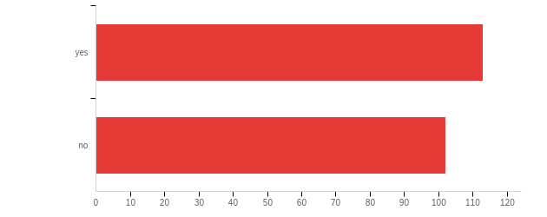

| # | Field | Minimum | Maximum | Mean | Std Deviation | Variance | Count |
| --- | --- | --- | --- | --- | --- | --- | --- |
| 1 | Have you contacted any presenters for more information? | 7.00 | 8.00 | 7.47 | 0.50 | 0.25 | 215 |

| # | Answer | % | Count |
| --- | --- | --- | --- |
| 7 | yes | 52.56% | 113 |
| 8 | no | 47.44% | 102 |
|  | Total | 100% | 215 |

**Q26 - Did you visit any exhibitors during the conference?**

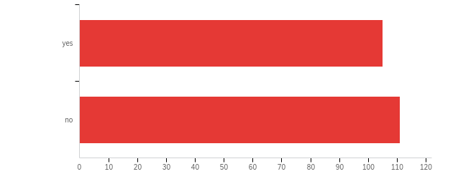

| # | Field | Minimum | Maximum | Mean | Std Deviation | Variance | Count |
| --- | --- | --- | --- | --- | --- | --- | --- |
| 1 | Did you visit any exhibitors during the conference? | 7.00 | 8.00 | 7.51 | 0.50 | 0.25 | 216 |

| # | Answer | % | Count |
| --- | --- | --- | --- |
| 7 | yes | 48.61% | 105 |
| 8 | no | 51.39% | 111 |
|  | Total | 100% | 216 |

**Q27 - What is your profession? Please select all that apply.**

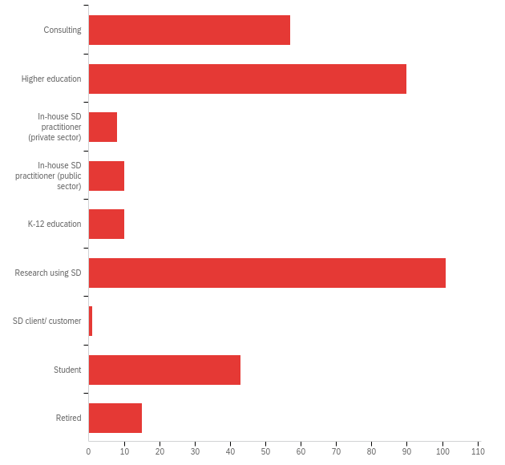

| # | Answer | % | Count |
| --- | --- | --- | --- |
| 1 | Consulting | 17.01% | 57 |
| 2 | Higher education | 26.87% | 90 |
| 3 | In-house SD practitioner (private sector) | 2.39% | 8 |
| 4 | In-house SD practitioner (public sector) | 2.99% | 10 |
| 5 | K-12 education | 2.99% | 10 |
| 6 | Research using SD | 30.15% | 101 |
| 7 | SD client/ customer | 0.30% | 1 |
| 8 | Student | 12.84% | 43 |
| 9 | Retired | 4.48% | 15 |
|  | Total | 100% | 335 |

**Q27b - Other (please specify)**

| Other (please specify) |
| --- |
| I advocate the use of SD for evaluation and formulation of Scientific and Technology Policy |
| Life coach, modeler |
| PhD-student-in-spe |
| Veterinarian--trying to bring SD to One Health complexity. |
| Business Analyst |
| Full-time SD (and DES) modeller working for a non-profit research institute (that works off of a consulting-type business model.. only really do commissioned work) |
| Non-profit |
| I am a Civil Engineer in practice. I study SD as a part-time student and would like to refocus my career in consulting using SD |
| Public Policy Professional working for the Government |
| L&D professional and PhD student |
| Safety Engineer |
| Do part-time adjunct teaching on systems thinking for Ph.D. students in leadership; customer of model for an experiential game that I use in training/consulting for federal gov. customer. Technically retired. |
| Storyteller |
| PhD |
| Public sector, currently not possible to use SD in my daily work |

**Q28 - What are your fields of interest? Please check all that apply.**

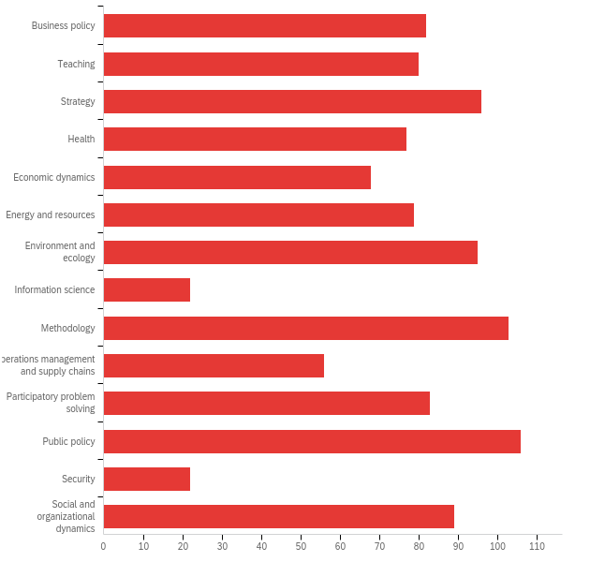

| # | Answer | % | Count |
| --- | --- | --- | --- |
| 1 | Business policy | 7.75% | 82 |
| 2 | Teaching | 7.56% | 80 |
| 3 | Strategy | 9.07% | 96 |
| 4 | Health | 7.28% | 77 |
| 5 | Economic dynamics | 6.43% | 68 |
| 7 | Energy and resources | 7.47% | 79 |
| 8 | Environment and ecology | 8.98% | 95 |
| 9 | Information science | 2.08% | 22 |
| 10 | Methodology | 9.74% | 103 |
| 11 | Operations management and supply chains | 5.29% | 56 |
| 12 | Participatory problem solving | 7.84% | 83 |
| 13 | Public policy | 10.02% | 106 |
| 14 | Security | 2.08% | 22 |
| 15 | Social and organizational dynamics | 8.41% | 89 |
|  | Total | 100% | 1058 |

**Q28b - Other (please specify)**

| Other (please specify) |
| --- |
| Risk analysis |
| Sport management / organisation |
| Applications of SD to History |
| agriculture and water dynamics |
| (Strategic) Human Resource Management |
| Sustainable agriculture |
| Dynamics of habit change, like wearing a mask, or brushing one’s teeth more often. |
| How to take research to real solutions |
| socio-ecological systems, group model building |
| Technology and innovation. |
| Sustainable Development |
| application of SD to tackle sustainability |
| Biomedical |
| And any not mentioned. It's all about relationships and their implications so it applied to everything. Makes it hard to focus. |
| Social Systems. Structural racism |
| Systems Thinking and its education and promotion |
| Problem conceptualization, multi-methods |
| Food and Ag |
| human behavior, social work, social change, social impact, public health, behavior change |

**Q29 - What is your geographic region?**

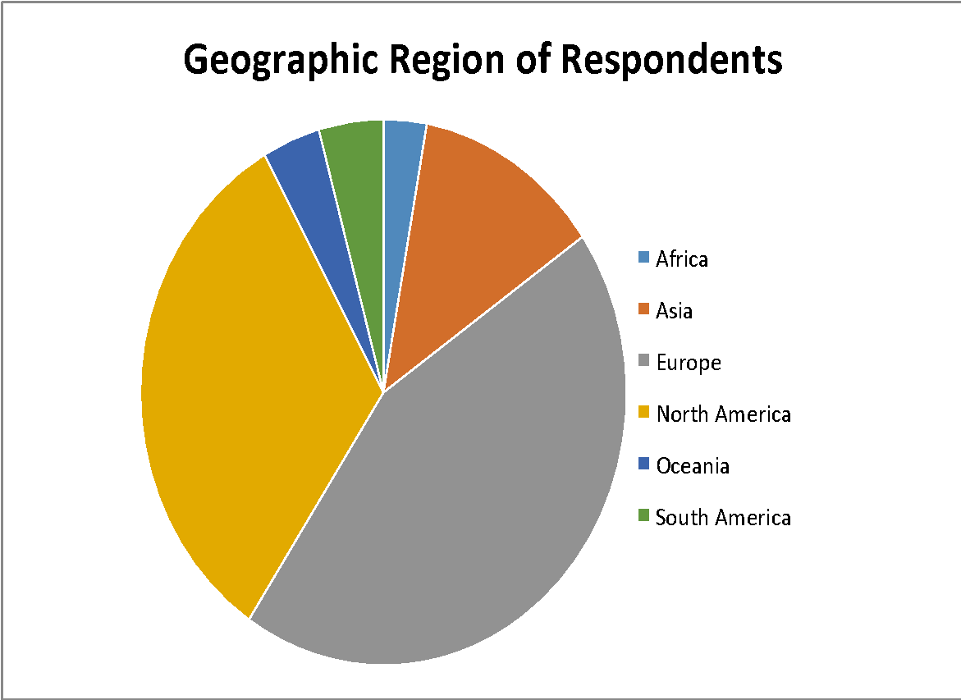

| # | Field | Count |
| --- | --- | --- |
| 1 | What is your geographic region? | 214 |

| # | Answer | % | Count |
| --- | --- | --- | --- |
| 1 | Africa | 2.80% | 6 |
| 2 | Asia | 12.15% | 26 |
| 3 | Europe | 45.33% | 97 |
| 4 | South America | 4.21% | 9 |
| 5 | North America | 31.77% | 68 |
| 6 | Oceania | 3.74% | 8 |
|  | Total | 100% | 214 |

**Q29b - Other (please specify)**

| Other (please specify) |
| --- |
| I work in Africa |
| + Asia |
| I am from Asia but I was in the U. S. during the conference. |
| Southern China - Asia pacific rim (including California) |
| I lived it! |
| European, currently working in Asia |
| Living in US but focusing on Asia,, primarily, especially Singapore, Sri Lanka and Chine |
| Fantastic, please see comments below. |
| India |
| Ukraine |
| Congratulations! participating in an online conference was a very interesting experience. THe organization groups together with the volunteers did a great job it was interesting and fun at the same time :-) |
|  |

**Q30 - If you have any suggestions for improvements that we can make for future conferences, please list them here.**

| If you have any suggestions for improvements that we can make for future conferences, please list them here. |
| --- |
| Make recorded session longer available e.g. till end of August (be aware the conference is in holliday time, so I had to view session during holliday). Make recorded sessions available to SD members as former conference procedings. |
| More of the voice + slides sreens and less of the zoom faces. At in=person conferences more interactive round table discussion rather than delivery presentations. 2 out of 3 conferences to be virtual to reduce costs. |
| I would like one month more to access the Zoom recorded conference. Also, It would be easy if we have a list with all links for the youtube presentations. |
| hybrid-format (face-to-face & virtual), match-making platform could be much more efficient than interest badges in finding like-minded people |
| I really appreciated having access to recordings during the conference. Especially as there were a lot of overlapping sessions that I wanted to attend, at least I was able to go back and see them after attending other sessions. In normal conferences, this isn't possible and the opportunity is missed. I also would like to have some sort of virtual networking or discussion groups in future. A hybrid conference sounds challenging to plan, but I really felt more able to speak up or converse with people in the virtual platform, which was surprising to me. Suggest looking at a hybrid in future! |
| This was amazing. I applaud the hard work that went into pivoting to a virtual conference. Thank you! |
| It was waaay too long throughout the day, it even felt like too much content, I was so tired on some days. For example, one day I had an echo at 7 am as a presenter and a roundtable at 11 pm as a chair. If you decide to go on with online conferences, maybe it would be an idea to stick to the program in one time zone (the zone of the host) and for others offer recordings. We always suffers due to jet-lag, it would not be much more different if someone had to wake up early or go to sleep late for an online conference. And definitely focus also on how to increase interaction between people. the 3d environment has a lot of unexploited potential. |
| Please continue in this virtual format next year! |
| All conference activities in 1 week. |
| I think the Echo sessions would be better if they were a full day later. I would train Echo session facilitators to raise discussion questions that can be answered without having watched the presentations. |
| Have a virtual component at all future conferences so that those that cannot afford to attend in person can still participate in this important event. Make the SD Colloquium a formal part of the ISDC since it seems somewhat disconnected. I'd recommend that the registration for the Colloquium not be separate to the ISDC a this leads to confusion for participants. |
| Get rid of the 3d. |
| Convratulations with a very successful arrangement! Regards from Jorgen Randers |
| I thought everyone did an amazing job of putting this together in a very short timeframe and overall it worked well--I am grateful for all that amazing effort and am very glad I attended. I would really like to see an online experience preserved in all future conferences, probably alongside a live experience. |
| Please, keep conference fee at the same level as this year (or less), forever. |
| There are pros and cons to this, but sometimes with the presentations, watching the pre-filmed videos was a little bit disconnected. However, those were often very well organized and succinct, where with the live ones, they were ore personal but sometimes distracted. I can absolutely agree with why they were filmed, but if we have to do virtual again, that connection may be nice. Also! The zoom format of the plenaries was great, and some of the larger parallel sessions would have benefited from that. |
| This may feel like a co-out to the SD purists, but if we (*gasp*) market ourselves slightly more with a systems thinking edge to it, I think we would attract more clients/customers which I think would help boost the numbers at the conferences. I think there should be more focus given on instructing authors to highlight the impact of their work and insights that came from it, and less so the technical aspects (technical presentations are dry as toast and almost impossible to understand in a 10 minute presentation). I would be really nice if we as a society made a few youtube videos that described things like "what makes a good ISDC presentation", what makes a good ISDC poster, etc, to help guide authors to better presentation formats. |
| It would be a good idea to organize the Conference in presence, but also think about providing virtual access for people not able to travel and attend and present. |
| Continue delivering a virtual format. Keep the recordings accessible for longer time or as members benefits. |
| Slack channel; small group video chat capability; topic-specific social sessions; more social activities |
| Continue to have a virtual option with recorded sessions even if we go back to live conferences. |
| I think the hybrid of real and virtual approach may be useful. |
| - Keep the recording, PLUS the CHAT! Do not forget - More practicioners. How to transfer knowledge from model building -&gt; Real solutions - How to fund SD projects in developing countries - Advanced powersim workshop (for adv. users) - Interesting to see more application on Model Quality tools. Sometimes this gets overlooked - How to bridge AI, Machine learning, Analytics (and every fad) to System Dynamics. Saw some presentations, but did not shared HOW to do that. - I think Senior or Experienced SD that attend and wish to help should be more visible. Sometimes it is hard to know as an experienced SD - Help "young" System Dynamicist to make a career of this. Maybe help them design their Roadmap, how to build their network, how to thrive as practicioner, researcher, both? etc. And the capitalist part, how do we make money and a living from this? (since it is not only for Enterprises, but for governments, start-ups, as a whole to solve complex problems.) How can SD people can make a living in this space? - Discounts for SD attendents for products/software, etc. - Expand the workshops! Those are facisnating but maybe through out the year continue learning once a month beyond the conference. The SD conference is the starter to continue. That will be amazing. |
| I think the student Colloquium utilized the online environments amazingly well and I would suggest consulting with them to improve the overall ISDC. Nonetheless, this was an amazing conference and I think the virtual success of the ISDC will reach all over the world. |
| Questions were poorly worded. For example, repeatedly asking "When it comes to..." is distracting. The response sets were OK, but could have been improved. Overall, this suggests more attention to detail in constructing surveys. |
| 1. It was good to have 3D experience but it would be better to make it more user-friendly. 2. It would be better if the number of presentations in social work can be increased. |
| The 2020 SDS Virtual Conference conference provided an epic experience not only in the deep learning but also the motivation to transfer this knowledge gained to my filed of education. |
| I hope to access all the resources that I missed during the conference with ease. |
| A reflection on how to build a "blended" format would be very valuable. I don't believe virtual conference will replace physical ones, but there are several features we've tested for the online conference that could be streamlined for the physical conferences in the future, such as some pre-recorded videos, availability of selected session to watch later (especially because ISDC programs tends to be huge and overwhelming) and the availability of the posters in digital format, among many other ideas. |
| It would be nice to have a google calendar that you could send out to everyone. That way, people can just add the calendar to their own calendars and it will automatically adjust to their time zones (even if it changes--especially earlier when the calendar was still the pdf online, it would have been nice to be able to plan some of my week ahead of time). There should also be some training for the moderators about which questions to ignore. There was one echo session I was in that got really off track and started debating totalitarianism versus democracy, and it took away a lot of time from people who actually had questions about the presentations |
| Offer an additional online version of the conference for people who cannot attend the conference money-wise or because they do not want to travel. Also, filming the sessions and granting attendees access to them is an awesome feature. |
| The option of attending in person whilst also continuing with virtual conference. |
| It's great that a truly international conference has been possible in 2020, and brought to life online. It's curious that although I've been 'attending' from home I still feel that I've been through an intense intellectual experience that has filled my mind with SD-related ideas, questions and doubts (just like a face-to-face event). I hope it will be possible to retain some serious component of an online experience even as-and-when ISDC returns to its normal in-person format. |
| Echo sessions need to be HOURS after live conference events end, maybe the next day. Overlapping sessions need more space; we twice had sessions that was against another session where a speaker had to leave 25 minutes before our session was over to be ready for the next session. The 3D world's glitches need to be addressed, as does training for that world that makes everyone comfortable using it. If it's virtual again, perhaps there could be smaller interest-based zooms during the conference that exist solely for the purpose of socializing, not talking about that subject. Or, I have seen in other virtual sessions, randomly putting people into their own breakout rooms to meet each other for 10 minutes, then coming back and sharing (an overarching personal topic helps everyone break the ice). I met and spoke with a small fraction of people I normally meet at the conference. |
| Virtual recordings seem like an excellent opportunity to enhance access in the future. I prefer in-person conferences if possible, but if it went virtual again I suggest spreading it out over more than one week. |
| It would be helpful to have an option where sessions selected from the general schedule are added to a personalised schedule. In this way, we can see easily where multiple sessions of interest overlap, and where we have "free" slots to attend other events/visit the exhibition/network with fellow practitioners outside sessions. |
| I just want to use this opportunity to thanks all conference organisers for the great job they did |
| Increase the connections with the business/policy makers world. |
| I think a blended offering would be ideal - face-to-face for those that can/want to attend, and a virtual component for those who can't. |
| I understand there will be requests to resume in-person conferences post C-19, but please make future conferences at least mostly virtual. Even in a post C-19 world I have very little inclination to go to Chicago (or any other major US destination), and destinations outside North America are cost-prohibitive. |
| Strive for elegance and simplicity, not simply excellence. Thanks. |
| I would like to have more time to watch the videos. I will not be able to get through them all by August 7th. |
| To be provided in a separate communication to SD Society leadership and staff. |
| I found it difficult to socialise - maybe there could be longer Q&A to allow time for discussions. |
| Would like to see more from practitioners and more sessions (parallels and plenaries, not just posters or exhibition places) focused around selling SD and addressing needs of clients in commercial applications of SD. |
| Overall, I would like to express that this has been and extraordinary event, and present my congratulations! All was excellent, and there was a very special and strong sense of community. Furthermore, participants also expressed kindness and support. I am both overwhelmed and grateful with is opportunity, as well as with the fact that I actually benefited form finantial support. Everything was so great, that the only thing I can suggets to improve in the communication through emails, which could perhaps occurless often, and paragraphs could be bullet points for more easy reading and communication (but I write a lot too, I know this is very good). All was excellent, thank you very much! Furthermore, it was an excellent package of Summer School, Colloquium, conference, and + workshops - trully outstanding! |
| I can only thank you all for the effort and the results in this conference. This was my first time and I feel part of it. That is amazing! |
| Some things worked better on zoom than in the traditional in person conference, and should be continued regardless of format in future: 1. questions for speakers submitted online and selected by a moderator. 2. polls (could be used even more especially to solicit questions moderator can then choose to ask of the speakers) 3. chat, allowing simultaneous broader engagement with the audience 4. use of pre-recorded and rehearsed presentations Other innovations are possible that would improve engagement and broader participation in e.g. comments and questions, such as use of google slides to allow simultaneous, parallel commenting and questioning instead of the serial format of chat and Q&A functions. |
| Come to Prague. Like seriously. The Czech University of Life Sciences Prague isn't the best CZ university but we have definitely the best campus in Prague. In case you would be interested to place some future conference to Prague, the faculty of Economics and Management could help. |
| No need to have 3D office hours - just have 3D hours. |
| I would really like to see a virtual conference every other year. It greatly reduces carbon footprints and lowers the threshold for access/participation. Also, especially with a conference in July, a digital conference means that I can participate without being away from my family in the summer (one the the main reasons I haven't participated before). |
| Please have a strategy for the use of the E-Mail. The organization team abused the E-Mail. I got bombarded with messages saying the same thing over and over again, to the point that I started deleting the E-Mails without reading them. More E-Mails do not make the message more clear, they just hide the information under piles of verbiage. |
| Leave long term access to the recording sessions and workshops for members of the SDS |
| I presenter WIP, the moderator decided to lump all discussions at the end of the session and at the echo. Interesting discussions, but I did not get specific questions or feedback on my paper, which was what I had expected and the main reason for me to participate |
| If we can download the recordings that would be great as we would keep reviewing them when needed. This would enhance the learning curve. |
| Provide a better way to locate and meet with other participants. |
| Thank you it was great |
| I believe recorded videos, especially of plenary sessions and workshops, is very important to allow broader participation and learning opportunities. |
| Congratulations for changing this unfortunate event to an extraordinary opportunity. I did not expect to enjoy and learn so much in this virtual conference. Thank you for not giving up. |
| Please held conference in dual (virtual and face to face ) format in the future |
| We should eliminate Echo sessions because authors are overloaded. Providing the video is sufficient. Attendees can ask a question via email. |
| Overall it was great from my experience. Workshops definitely flow best if everyone is prepared with downloaded materials or new accounts/logins or technical needs beforehand (some presenters were great at sending out that info and prep instructions or pre-reading via email, some workshops lost a lot of time setting up accounts and/or getting used to formats). |
| Schedule page = went right back up to the top after you favourited something which was annoyiing and made it unfriendly. Would be good to integrate with calendar apps so favouriting generated a diary entry. |
| A hybrid conference with virtual and in-person components would be ideal. |
| The hard work of the conference organizers is really appreciated. As much as I like face to face conferences I did talk with many people who really liked the virtual format and said that it was the only way that they could attend. What ever we do for face to face conferences, for the sake of inclusion and diversity we have to keep a virtual option available that makes everyone feel welcome. |
| I think you did a brilliant job at rescuing the conference given the restrictions. I am sure many benefitted. The format is just not for me though. i was zoomed out before it started due to coping with lockdown. |
| A hybrid in-person and online format might allow for best of both worlds - more access for those who can't travel (though maybe not the full experience) while allowing for the great in-person random interactions that can only happen face-to-face. |
| That sort of depends on the real intent of the conference now doesn't it? |
| Find ways of using Zoom and other video platforms for enabling people to interact. The 3D space with avatars was a cute idea, but felt too artificial to be enjoyable. A hybrid conference allowing in-person and virtual attendance would be the best of both worlds and meet everyone's social and intellectual needs. |
| If it is possible to continue with an online dimension when F2F conferences resume it will be very helpful for many reasons, particularly managing our carbon budget. |
| Next conferences should have joint face-to-face and virtual formats! |
| Some blend of "live" and virtual will include more people in the great work to be presented at future conferences. |
| Thanks to program chairs. It was wonderful. And obviously a lot of work. Thanks for your service to the SD community. |
| Some combination of live and virtual would be nice. It was great to talk to people who said they would not have participated otherwise. Maye ever other year live and every other just regional chapters with common plenary sessions, recordings of presentations and online program with contact detais cross-continent. :-) Thank you all, it was way more than expected and a great experience! I was really happy that you took the challenge and did not cancel it! |
| Thx. It was outstanding what you achieved within this short period of time - For me there is no going back - A hybrid approach - IMHO - is the future |
| For those of us who might have trouble traveling (expense, permission for overseas travel, etc.), this virtual format was great! |
| I think it will be important for the society to consider carefully George Richardson's "manifesto" on qualitative system dynamics. How can we as a society encourage "good" work that does not involve simulations (or that involves really simple simulations)? |
| You should enlarge the scope with sociologist or other « soft » system dynamics experts to have a bigger picture. I am disappointed the quite narrow view of system dynamics represented to the event. |
| Don't get stuck with either / or scenarios, e.g. of whether to have an only virtual or only face2face conference; a combination of both may work very well; or alternating with virtual onces at least, as it both decreases the budgetary expenses and footprint of researches - and opens one's mind for another kind of conversations and interactions! |
| You might want to ask presenters to attend, for sure, their "echo" sessions. I watched a recorded session and went to the echo to ask a question of one of the participants, but he did not attend. |
| The virtual conference is a great opportunity for those without the means to travel for the conference. It's cheap, it allows people to present their work, i think the virtual setting should be integrated with the face to face format to allow more participation and boost spreading SD work |
| the time schedule of some programs may be improved so that most participants feel comfortable to attend. |
| I would love it if you would reconsider your site navigation. I found it really tedious to scroll through the sessions day by day with all the content pre-expanded for me. In most conferences that I've attended with lots of content, there is a high level listing for each day and you can bounce around from one day to the next via tabs at the top, then scroll down the times and titles of each session. if you're interested in a title, clicking on it either expands to show the detailed content or pops up a window to show it. There is also a separate tab with favorites or tagged sessions. this makes it very easy to navigate through a lot of content quickly, select what you want to participate in, and collect it in one place for instant reference. There should also be someplace on the site to look up attendees or to download an Excel or CSV file of attendee data for those who want to share their contact info. Printing PDFs makes it very difficult to see, for example, who is coming from a particular company or country or state or whatever. Overall, the conference had great value for me. I hope next year is even better! |
| The schedule was very click-y. It might be nice to have two versions: one abbreviated version with just the times and session types, and another with everything listed out so you don't have to click on every talk. |